

**MANUAL BOOK**

**SISTEM INFORMASI PENDAFTARAN, E-RAPORT DAN**

**PRESTASI SISWA DI SDIT DAARUL FATAA**

**BOJONG GEDE BOGOR**

**BERBASIS JAVA**

Nama : Akbar ‘Asif Subagiyo

NPM : 201743501717

Kelas : R8Y

Program Studi : Teknik Informatika

**PENGANTAR**

Assalammu’alaikum Warohmatullahi Wabarokaatuh,

Alhamdulillahirabbil’alaamiin

Segala puji dan syukur kepada Allah SWT yang telah melimpahkan rahmat, hidayah serta inayah-Nya sehingga akhirnya penulis dapat menyelesaikan Manual Book penggunaan Sistem Informasi Pendaftaran, E-Raport dan Prestasi Siswa di SDIT Daarul Fataa Bojong Gede Bogor Berbasis Java. Penulis menyadari bahwa manual book ini masih jauh dari sempurna, sehingga diharapkan kepada para pembaca agar berkenan memberikan kritik dan sarannya yang bersifat membangun untuk perbaikan untuk kedepannya. Semoga panduan ini dapat bermanfaat bagi pembaca maupun penulis. Akhir kata penulis ucapkan terimakasih.

Wassalammualaikum Warohmatullahi Wabarakatuh

Jakarta, 24 Mei 2021

Akbar ‘Asif Subagiyo

**DAFTAR ISI**

Cover 1

Pengantar 2

Daftar Isi 3

I. Pendahuluan 5

II. Spesifikasi Sistem Komputer yang digunakan 6

III. Perangkat Lunak yang digunakan 6

IV. Tampilan Login 7

V. Tampilan Menu Utama 8

VI. Tampilan Menu Siswa 9

VII. Tampilan Menu Guru 10

VIII. Tampilan Menu Absensi Siswa 11

VIX. Tampilan Menu Absensi Guru 12

X. Tampilan Menu Jadwal 13

XI. Tampilan Menu Nilai 14

XII. Tampilan Menu Prestasi Siswa 15

XIII. Tampilan Menu Laporan Absensi Siswa 16

XIV. Tampilan Menu Laporan Absensi Guru 17

XV. Tampilan Menu Laporan Nilai Raport 18

XVI. Tampilan Menu Laporan Prestasi Siswa 19

XVII. Laporan Data Siswa 20

XVIII. Laporan Data Guru 21

XIX. Laporan Absensi Siswa Harian 22

XX. Laporan Absensi Siswa Perbulan 23

XXI. Laporan Absensi Guru Harian 24

XXII. Laporan Absensi Guru Perbulan 25

XXIII. Laporan Jadwal 26

XXIV. Laporan Nilai Raport Seluruh Siswa 27

XXV. Laporan Nilai Raport Persiswa 28

XXVI. Laporan Prestasi Seluruh Siswa 29

XXVII. Laporan Prestasi Persiswa 30

XXVIII. Listing Program / Source Code 31

**I. Pendahuluan**

Dengan dibuatnya Sistem Informasi Pendaftaran, Absensi, Raport dan Prestasi Siswa semua kegiatan yang berhubungan dengan Pendaftaran, Absensi, Raport dan Prestasi Siswa dapat berjalan dengan efektif dan efisien. Pada sistem ini, bagian Personalia dan bagian Pendataan dapat menangani pekerjaan penginputan data – datanya dengan cepat dan akurat serta dapat di *update* dengan mudah. Dan dengan adanya sistem ini diharapkan akan mempermudah kegiatan atau memerlukan kecepatan ketetapan informasi.

Kecepatan dan ketepatan hasil sistem ini juga membutuhkan partisipasi aktif dari pemakaian sistem, terutama kedisiplinan para pelaksana yang menangani secara langsung pada sistem. Dengan adanya jasa komputer sebagai alat bantu, penulis mempunyai simpulan dengan menggunakan sistem ini berdasarkan perumusan masalah sebagai berikut:

1. Rancangan sistem informasi pendaftaran, absensi, raport dan prestasi siswa lebih efektif dan efisien dalam pengolahan datanya.
2. Membuat laporan rekapitulasi pendaftaran, absensi, raport dan prestasi siswa yang lebih cepat dan akurat.

Dengan diterapkannya sistem ini berbasis Dekstop merupakan salah satu Langkah maju dalam penerapan teknologi informasi. Sistem informasi pendaftara, absensi, raport dan prestasi siswa yang penulis buat hanya untuk mengefisienkan waktu dan keamanan data yang setidaknya dapat membantu bagian personalia dan pendataan diddalam pengolahan datanya.

**II. Spesifikasi Sistem Komputer yang digunakan**

Perangkat keras (hardware) yang digunakan untuk mendukung program ini :

1. Processor : AMDA A9

2. RAM : 8 GB

3. Harddisk : 500 GB

4. Keyboard : Standar Keyboard

5. Mouse : Standar Mouse

6. Printer : Epson L360

**III. Perangkat Lunak yang digunakan**

Perangkat Lunak (software) yang digunakan untuk mendukung program ini :

1. Sistem Operasi : Microsoft Window 2010

2. Bahasa Pemrograman : Netbeans IDE 8.2

3. Basis Data : PhpMyAdmin 127.0.0.1

**IV. Tampilan Login**

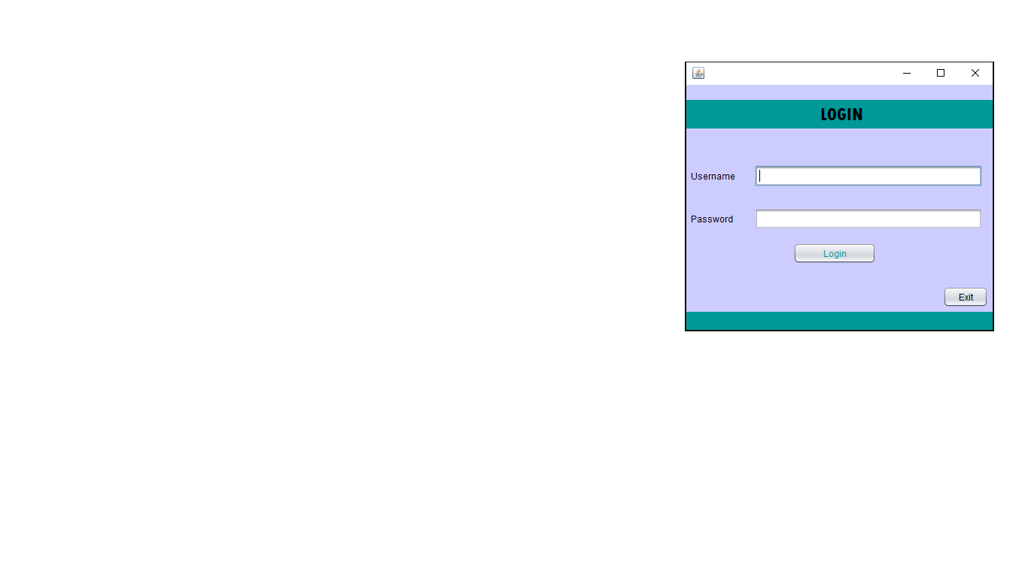

Pertama tama, masukan Username yang sudah tersedia selanjutnya isi Password yag sudah tersedia, jika sudah klik tombol Login nanti akan ada pesan dialog sebelum masuk ke menu utama.

**V. Tampilan Menu Utama**

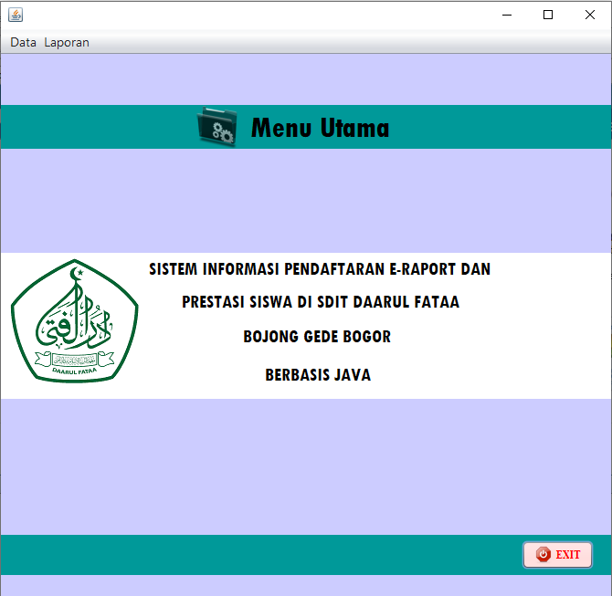

Tampilan Menu Awal yang dibuat, terdapat menu aplikasi yang nantinya jika ingin menekan pada tombol menu data maka akan ada pilihan berupa menu *form* siswa, *form* guru, *form* prestasi siswa, absensi siswa, absensi guru, *form* nilai dan *exit*.

**VI. Tampilan Menu Siswa**

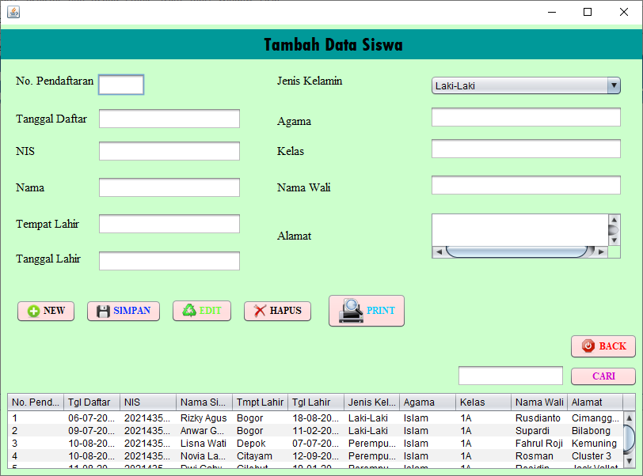

Tampilan menu *form* siswa terdapat, No Pendaftaran, Tanggal daftar NIS, Nama, Tempat Lahir, Tanggal Lahir, Jenis Kelamin Agama, Kelas, Nama Wali dan Alamat, wali murid tinggal mengisi *field-field* yang sudah tersedia. Dan bisa mengedit, menyimpan, menghapus, membuat data baru, print dan ada tombol back dan cari.

**VII. Tampilan Menu Guru**

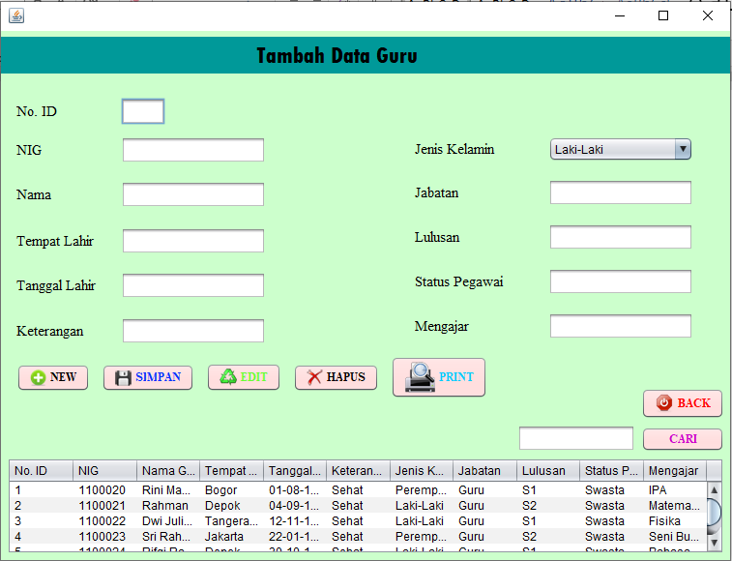

Tampilan menu *form* guru terdapat No. ID, NIG, Nama, Tempat Lahir, Tanggal Lahir, Keterangan, Jenis Kelamin, Jabatan, Lulusan, Status Pegawai, dan Mengajar. Guru tinggal mengisi *field-field* yang sudah tersedia. Dan bisa mengedit, menyimpan, menghapus, membuat data baru, print dan ada tombol back dan cari.

**VIII. Tampilan Menu Absensi Siswa**

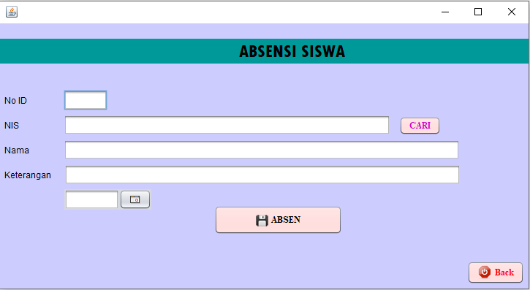

Tampilan menu absensi siswa terdapat No. ID, NIS, Nama, Keterangan, dan Tanggal hari ini. Guru tinggal mengisi *field-field* yang sudah tersedia. Dan guru tinggal klik tombol absen, dan tombol back untuk kembali ke menu utama.

**IX. Tampilan Menu Absensi Guru**

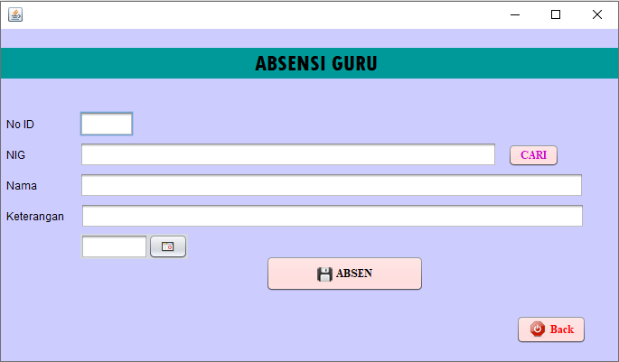

Tampilan Menu Absensi Guru terdapat No.ID, NIG, Nama Guru, Keterangan dan Tanggal hari ini. Guru tinggal mengisi *field-field* yang sudah tersedia. Dan guru tinggal klik tombol absen, dan tombol back untuk kembali ke menu utama.

**X. Tampilan Menu Form Jadwal**

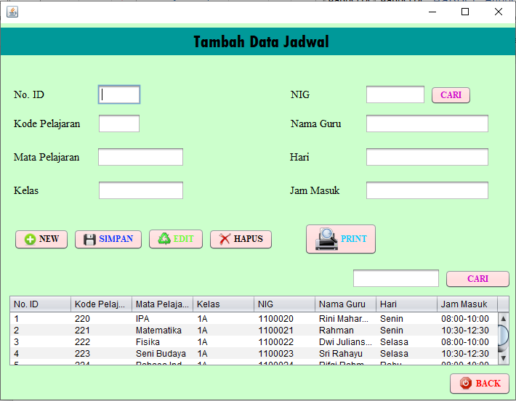

Tampilan Menu Jadwal terdapat No. ID, Kode Pelajaran, Mata Pelajaran, Kelas, NIG, Hari, dan Jam Masuk. Guru tinggal mengisi *field-field* yang sudah tersedia. Dan bisa mengedit, menyimpan, menghapus, membuat data baru, print dan ada tombol back dan cari.

**XI. Tampilan Menu Form Nilai**

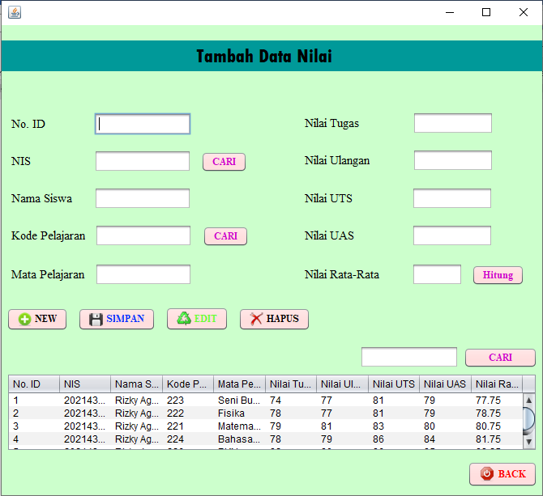

Tampilan Menu Nilai Siswa terdapat No.ID, NIS, Nama Siswa, Mata Pelajaran, Nilai Tugas, Nilai Ulangan, Nilai UTS, Nilai UAS. Guru tinggal mengisi *field-field* yang sudah tersedia. Dan bisa mengedit, menyimpan, menghapus, membuat data baru dan ada tombol back dan cari.

**XII. Tampilan Menu Prestasi Siswa**

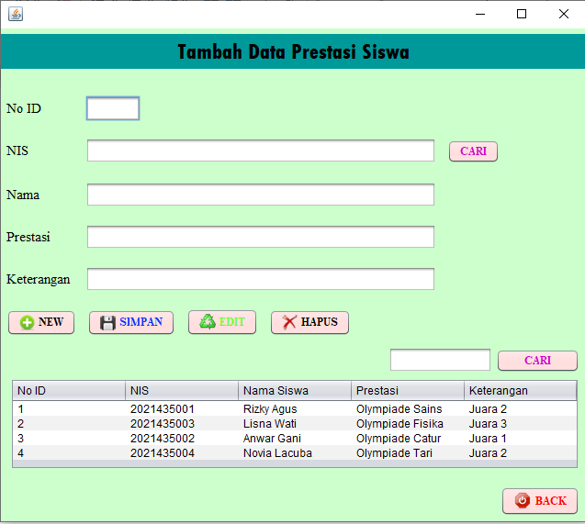

Tampilan menu *form* prestasi siswa terdapat No.ID, NIS, Nama, Prestasi, Keterangan. admin tinggal mengisi *field-field* yang sudah tersedia. Dan bisa mengedit, menyimpan, menghapus, membuat data baru dan ada tombol back dan cari

**XIII. Tampilan Menu Laporan Absensi Siswa**

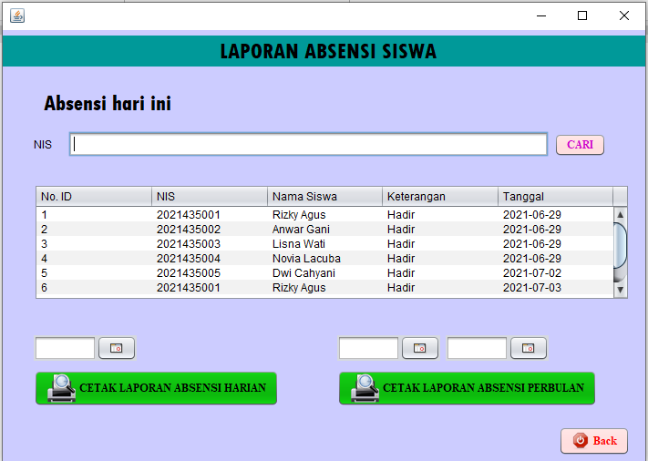

Tampilan Menu Laporan Absensi Siswa terdapat No. ID, NIS Pencarian, Tabel *form* yang berisikan No. ID, NIS,Nama Siswa, Keterangan, dan Tanggal , lalu ada tombol Cetak Laporan Absensi Harian dan Cetak Laporan Absensi Perbulan dan tombol *back* untuk kembali ke menu utama.

**XIV. Tampilan Menu Laporan Absensi Guru**

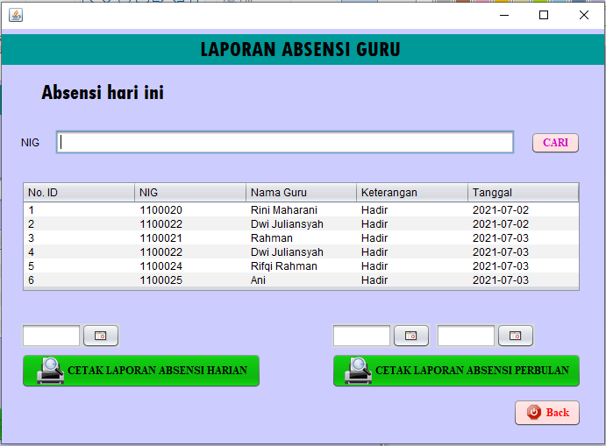

Tampilan Menu Laporan Absensi Guru terdapat No. ID, NIG Pencarian, Tabel *form* yang berisikan No.ID, NIS, Nama Guru, Keterangan, dan Tanggal , lalu ada tombol Cetak Laporan Absensi Harian dan Cetak Laporan Absensi Perbulan dan tombol *back* untuk kembali ke menu utama.

**XV. Tampilan Menu Laporan Nilai Raport**

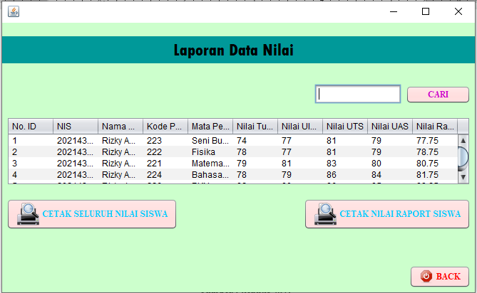

Tampilan Menu Laporan Nilai Raport berisikan kolom pencarian dan tombol pencarian, tabel data nilai berupa No.ID, NIS, Nama Siswa, Kode Pelajaran, Mata Pelajaran, Nilai Tugas, Nilai Ulangan, Nilai UTS, Nilai UAS, Nilai Rata-Rata, dan tombol cetak seluruh nilai siswa , cetak nilai raport siswa dan tombol *back* untuk kembali ke menu utama.

**XVI. Tampilan Menu Laporan Prestasi Siswa**

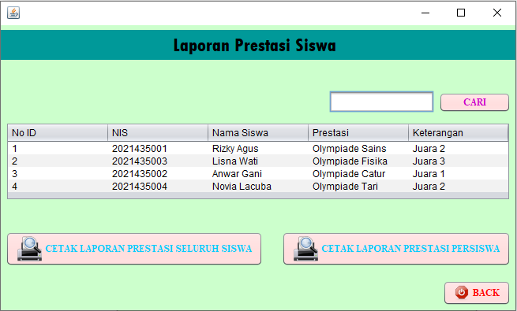

Tampilan Menu Laporan Prestasi Siswa berisikan kolom pencarian dan tombol pencarian, tabel data berupa No.ID, NIS, Nama Siswa, Prestasi, Keterangan, tombol cetak seluruh prestasi siswa , cetak prestasi persiswa dan tombol *back* untuk kembali ke menu utama.

**XVII. Laporan Data Siswa**

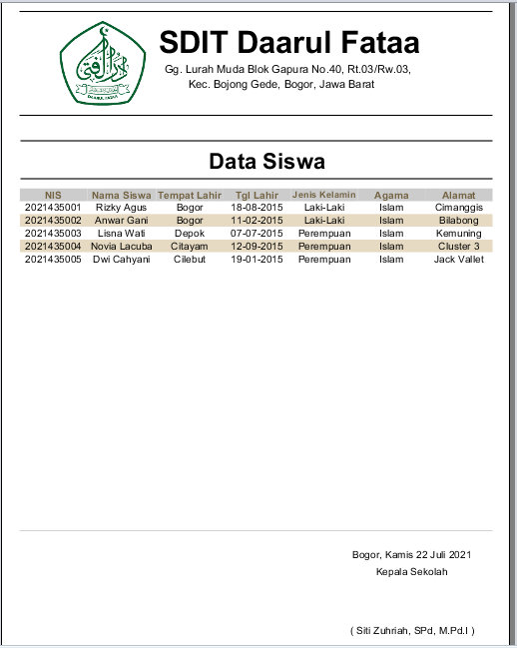

Pada Tampilan layar diatas adalah Laporan Data Siswa pada SDIT Daarul Fataa.

**XVIII. Laporan Data Guru**

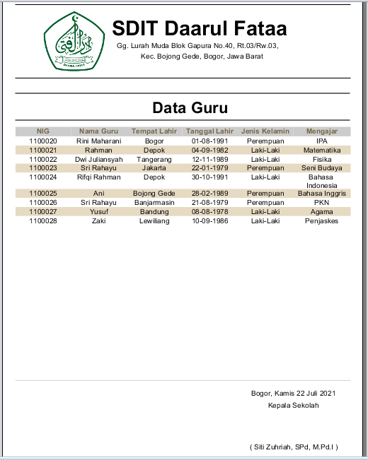

Pada Tampilan layar diatas adalah Laporan Data Guru – Guru pada SDIT Daarul Fataa.

**XIX. Laporan Absensi Siswa Harian**

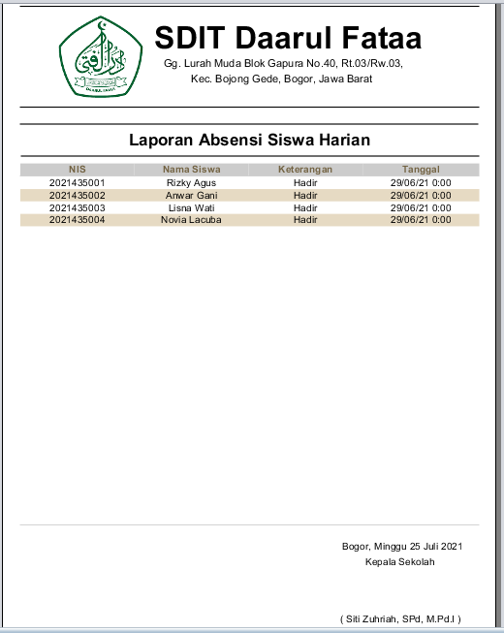

Pada Tampilan layar diatas adalah Laporan Data Absensi Siswa Harain yang sudah terinput sesuai hari itu juga.

**XX. Laporan Absensi Siswa Perbulan**

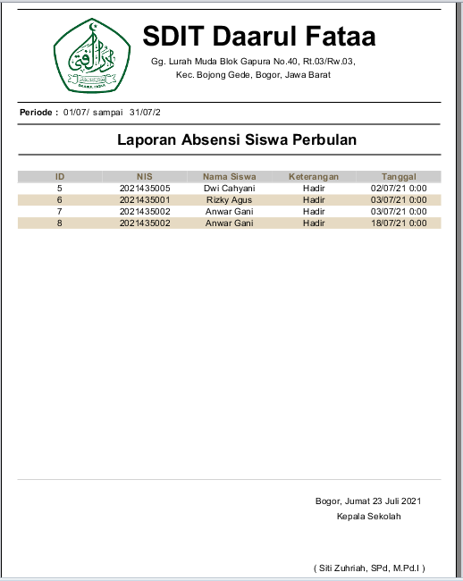

Pada Tampilan layar diatas adalah Laporan Data Absensi Bulanan Siswa pada SDIT Daarul Fataa.

**XXI. Laporan Absensi Guru Harian**

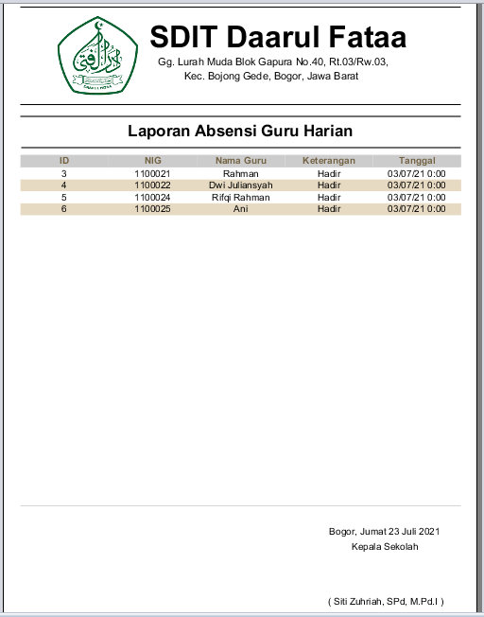

Pada Tampilan layar diatas adalah Laporan Data Absensi Guru Harain yang sudah terinput pada hari itu juga.

**XXII. Laporan Absensi Guru Bulanan**

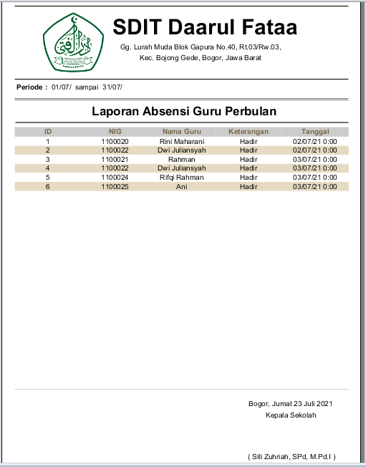

Pada Tampilan layar diatas adalah Laporan Data Absensi Bulanan Guru pada SDIT Daarul Fataa.

**XXIII. Laporan Jadwal**

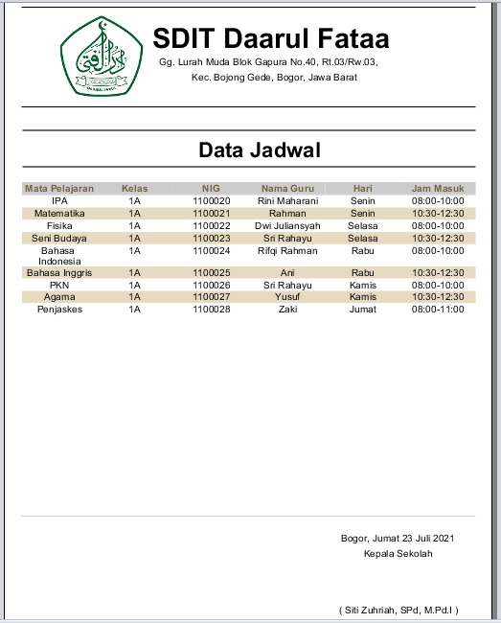

Pada Tampilan layar diatas adalah Laporan Data Jadwal Pelajaran dan Mengajar pada SDIT Daarul Fataa.

**XXIV. Laporan Nilai Raport Seluruh Siswa**

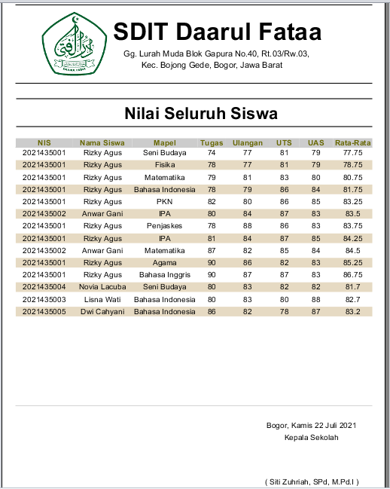

Pada Tampilan layar diatas adalah Laporan Data Nilai Seluruh Siswa yang sudah diperhitungkan satu semesternya.

**XXV. Laporan Nilai Raport Persiswa**

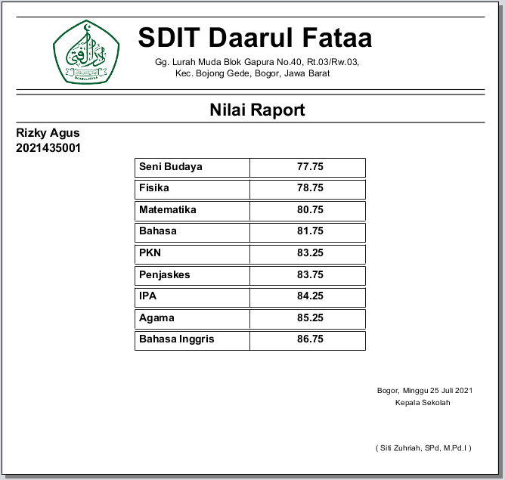

Pada Tampilan layar diatas adalah Laporan Data Nilai Raport Persiswa yang sudah diperhitungkan satu semesternya.

**XXVI. Laporan Prestasi Seluruh Siswa**

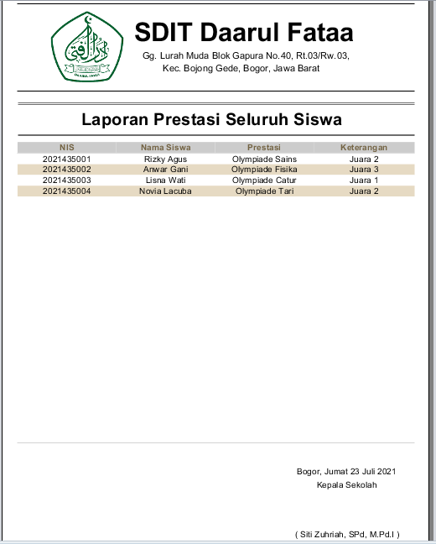

Pada Tampilan layar diatas adalah Laporan Seluruh Data Prestasi Siswa yang diraih disuatu perlombaan atau prestasinya.

**XXVII. Laporan Prestasi Persiswa**

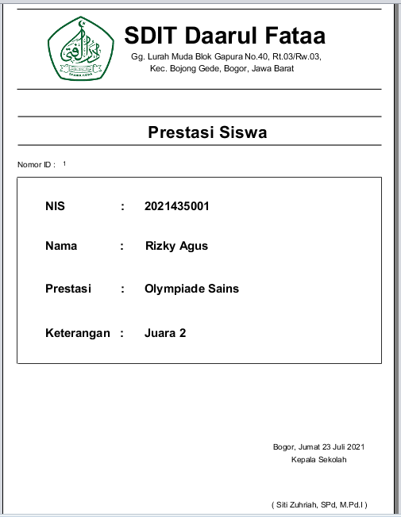

Pada Tampilan layar diatas adalah Laporan Data Prestasi Persiswa yang diraih disuatu perlombaan atau prestasinya.

**XXVIII. Listing Program / Source Code**

1. **Menu Login**

package Form;

import javax.swing.JOptionPane;

import com.mysql.jdbc.Connection;

import java.sql.ResultSet;

import java.sql.SQLException;

import java.sql.Statement;

import java.util.logging.Level;

import java.util.logging.Logger;

import javax.swing.JOptionPane;

import Connect.koneksi;

/**

*

* @author user

*/

public class Login extends javax.swing.JFrame {

/**

* Creates new form Login

*/

public Login() {

initComponents();

}

public void cek() throws SQLException{

Connection kon = (Connection) Connect.koneksi.getConnection();

try{

Statement statement = kon.createStatement();

String sql = "SELECT * FROM login WHERE username = '"+tuser.getText()+"' and password ='"+tpass.getText()+"'";

ResultSet kr = statement.executeQuery(sql);

if (kr.next()){

JOptionPane.showMessageDialog(null, "Login Berhasil");

if(kr.getString("level").equals("admin")){

Form.Menu ka = new Form.Menu();

ka.show();

this.dispose();

}

}else{

JOptionPane.showMessageDialog(null, "Maaf Password Atau Username anda salah");

tuser.setText("");

tpass.setText("");

tuser.requestFocus();

}

}catch (Exception e){

JOptionPane.showMessageDialog(null, e);

}

}

private void blogActionPerformed(java.awt.event.ActionEvent evt) {

try {

cek();

} catch (SQLException ex) {

Logger.getLogger(Login.class.getName()).log(Level.SEVERE, null, ex);

}

}

private void bexitActionPerformed(java.awt.event.ActionEvent evt) {

dispose();

}

1. **Menu Utama**

package Form;

import java.sql.Connection;

import java.sql.DriverManager;

import java.util.HashMap;

import net.sf.jasperreports.engine.JasperFillManager;

import net.sf.jasperreports.engine.JasperPrint;

import net.sf.jasperreports.view.JasperViewer;

/**

*

* @author user

*/

public class Menu extends javax.swing.JFrame {

/**

* Creates new form Menu

*/

public Menu() {

initComponents();

//setLocationRelativeTo(null);

//this.setExtendedState

int name = (Menu.MAXIMIZED_BOTH)|this.getExtendedState();

}

private void jMenuItem5ActionPerformed(java.awt.event.ActionEvent evt) {

new Project.Jadwal().setVisible(true);

this.dispose();

}

private void jMenuItem12ActionPerformed(java.awt.event.ActionEvent evt) {

new Project.Lap_Nilai().setVisible(true);

this.dispose();

}

private void bkeluar1ActionPerformed(java.awt.event.ActionEvent evt) {

dispose();

}

private void jMenu1ActionPerformed(java.awt.event.ActionEvent evt) {

Project.Siswa xx;

xx = new Project.Siswa();

xx.setVisible(true);

this.dispose();

}

private void jMenuItem1ActionPerformed(java.awt.event.ActionEvent evt) {

new Project.Siswa().setVisible(true);

this.dispose();

}

private void jMenuItem2ActionPerformed(java.awt.event.ActionEvent evt) {

new Project.Guru().setVisible(true);

this.dispose();

}

private void jMenuItem3ActionPerformed(java.awt.event.ActionEvent evt) {

new Project.Presensi().setVisible(true);

this.dispose();

}

private void jMenuItem4ActionPerformed(java.awt.event.ActionEvent evt) {

new Project.Presensi_Guru().setVisible(true);

this.dispose();

}

private void jMenuItem6ActionPerformed(java.awt.event.ActionEvent evt) {

new Project.Prestasi().setVisible(true);

this.dispose();

}

private void jMenuItem9ActionPerformed(java.awt.event.ActionEvent evt) {

new Project.Nilai().setVisible(true);

this.dispose();

}

private void jMenuItem10ActionPerformed(java.awt.event.ActionEvent evt) {

new Project.Data_Absensi_Siswa().setVisible(true);

this.dispose();

}

private void jMenuItem11ActionPerformed(java.awt.event.ActionEvent evt) {

new Project.Data_Presensi_Guru().setVisible(true);

this.dispose();

}

private void jMenuItem13ActionPerformed(java.awt.event.ActionEvent evt) {

new Project.Lap_Prestasi().setVisible(true);

this.dispose();

}

1. **Menu Data Siswa**

package Project;

import com.mysql.jdbc.Statement;

import java.awt.HeadlessException;

import java.sql.Connection;

import java.sql.DriverManager;

import java.sql.ResultSet;

import java.sql.SQLException;

import javax.swing.JOptionPane;

import Connect.koneksi;

import javax.swing.table.DefaultTableModel;

import Form.*;

import java.io.File;

import java.util.HashMap;

import java.util.Locale;

import net.sf.jasperreports.engine.JasperFillManager;

import net.sf.jasperreports.engine.JasperPrint;

import net.sf.jasperreports.engine.JasperReport;

import net.sf.jasperreports.engine.util.JRLoader;

import net.sf.jasperreports.view.JasperViewer;

/**

*

* @author user

*/

public class Siswa extends javax.swing.JFrame {

/**

* Creates new form Siswa

*/

public Siswa() {

initComponents();

datatable();

Locale locale = new Locale ("id","ID");

Locale.setDefault(locale);

}

private void datatable(){

DefaultTableModel tbl= new DefaultTableModel();

tbl.addColumn("No. Pendaftaran");

tbl.addColumn("Tgl Daftar");

tbl.addColumn("NIS");

tbl.addColumn("Nama Siswa");

tbl.addColumn("Tmpt Lahir");

tbl.addColumn("Tgl Lahir");

tbl.addColumn("Jenis Kelamin");

tbl.addColumn("Agama");

tbl.addColumn("Kelas");

tbl.addColumn("Nama Wali");

tbl.addColumn("Alamat");

tabel.setModel(tbl);

try{

Statement statement = (Statement) koneksi.getConnection().createStatement();

ResultSet res = statement.executeQuery("SELECT * FROM siswa");

while (res.next())

{

tbl.addRow(new Object[]{

res.getString("no_daftar"),

res.getString("tgl_daftar"),

res.getString("nis"),

res.getString("nama_siswa"),

res.getString("tempat_lahir"),

res.getString("tgl_lahir"),

res.getString("jk"),

res.getString("agama"),

res.getString("kelas"),

res.getString("wali"),

res.getString("alamat"),

});

tabel.setModel(tbl);

}

}catch (Exception e){

JOptionPane.showMessageDialog(rootPane, "Gagal");

}

}

private void tabelMouseClicked(java.awt.event.MouseEvent evt) {

int i = tabel.getSelectedRow();

if (i == -1){

return;

}

String no_daftar = (String) tabel.getValueAt(i, 0);

txtno_daftar.setText(no_daftar);

String tgl_daftar = (String) tabel.getValueAt(i, 1);

txtdaftar.setText(tgl_daftar);

String nis = (String) tabel.getValueAt(i, 2);

txtnis.setText(nis);

String nama_siswa = (String) tabel.getValueAt(i, 3);

txtnama.setText(nama_siswa);

String tempat_lahir = (String) tabel.getValueAt(i, 4);

txtlahir.setText(tempat_lahir);

String tgl_lahir = (String) tabel.getValueAt (i, 5);

txttgl.setText(tgl_lahir);

String jk = (String) tabel.getValueAt(i, 6);

cmbjk.setSelectedItem(jk);

String agama = (String) tabel.getValueAt(i, 7);

txtagama.setText(agama);

String kelas = (String) tabel.getValueAt(i, 8);

txtkelas.setText(kelas);

String wali = (String) tabel.getValueAt(i, 9);

txtwali.setText(wali);

String alamat = (String) tabel.getValueAt (i, 10);

txtalmt.setText(alamat);

}

private void btambahActionPerformed(java.awt.event.ActionEvent evt) {

txtno_daftar.setText("");

txtdaftar.setText("");

txtnis.setText("");

txtnama.setText("");

txtlahir.setText("");

txttgl.setText("");

cmbjk.setSelectedItem("Laki-laki");

txtagama.setText("");

txtkelas.setText("");

txtwali.setText("");

txtalmt.setText("");

txtno_daftar.requestFocus();

}

private void bsimpanActionPerformed(java.awt.event.ActionEvent evt) {

String no_daftar = txtno_daftar.getText();

String tgl_daftar = txtdaftar.getText();

String nis = txtnis.getText();

String nama_siswa = txtnama.getText();

String tempat_lahir = txtlahir.getText();

String tgl_lahir = txttgl.getText();

String jk = (String) cmbjk.getSelectedItem();

String agama = txtagama.getText();

String kelas = txtkelas.getText();

String wali = txtwali.getText();

String alamat = txtalmt.getText();

try{

Statement statement = (Statement)koneksi.getConnection().createStatement();

statement.executeUpdate("INSERT INTO siswa VALUES ('"+no_daftar+"','"+tgl_daftar+"','"+nis+"','"+nama_siswa+"','"+tempat_lahir+"','"+tgl_lahir+"','"+jk+"','"+agama+"','"+kelas+"','"+wali+"','"+alamat+"')");

statement.close();

JOptionPane.showMessageDialog(null, "Data Berhasil disimpan");

}catch (Exception t){

JOptionPane.showMessageDialog(null, "Data Gagal disimpan");

}

datatable();

}

private void beditActionPerformed(java.awt.event.ActionEvent evt) {

if (bedit.getText() == "bedit"){

txtno_daftar.requestFocus();

}else{

String no_daftar = txtno_daftar.getText();

String tgl_daftar = txtdaftar.getText();

String nis = txtnis.getText();

String nama_siswa = txtnama.getText();

String tempat_lahir = txtlahir.getText();

String tgl_lahir = txttgl.getText();

String jk = (String) cmbjk.getSelectedItem();

String agama = txtagama.getText();

String kelas = txtkelas.getText();

String wali = txtwali.getText();

String alamat = txtalmt.getText();

try{

Statement statement = (Statement)koneksi.getConnection().createStatement();

statement.executeUpdate("update siswa SET no_daftar='"+no_daftar+"',tgl_daftar='"+tgl_daftar+"',"+"nis='"+nis+"',"+"nama_siswa='"+nama_siswa+"',"+"tempat_lahir='"+tempat_lahir+"',"+"tgl_lahir='"+tgl_lahir+"',"+"jk='"+jk+"',"+"agama='"+agama+"',"+"kelas='"+kelas+"',"+"wali='"+wali+"',"+"alamat='"+alamat+"'"+"WHERE no_daftar = '"+no_daftar+"' OR nis='"+nis+"'");

statement.close();

JOptionPane.showMessageDialog(null, "Data Berhasil Diubah");

}catch (Exception t){

JOptionPane.showMessageDialog(null, "Data Gagal Diubah");

}

datatable();

}

}

private void bhapusActionPerformed(java.awt.event.ActionEvent evt) {

String no_daftar = txtdaftar.getText();

String nis = txtnis.getText();

try{

Statement statement = (Statement)koneksi.getConnection().createStatement();

statement.executeUpdate("delete from siswa WHERE no_daftar='"+no_daftar+"' OR nis='"+nis+"';");

JOptionPane.showMessageDialog(null, "Data Berhasil di hapus");

txtno_daftar.setText("");

txtdaftar.setText("");

txtnis.setText("");

txtnama.setText("");

txtlahir.setText("");

txttgl.setText("");

cmbjk.setSelectedItem("Laki-laki");

txtagama.setText("");

txtkelas.setText("");

txtwali.setText("");

txtalmt.setText("");

}catch (Exception t){

JOptionPane.showMessageDialog(null, "Data Gagal dihapus");

}

datatable();

}

private void bkeluarActionPerformed(java.awt.event.ActionEvent evt) {

Menu xx;

xx = new Menu();

xx.setVisible(true);

this.dispose();

}

private void bcariActionPerformed(java.awt.event.ActionEvent evt) {

try{

Statement statement = (Statement)koneksi.getConnection().createStatement();

ResultSet res = statement.executeQuery("SELECT * FROM siswa where "+"no_daftar like '%"+txtcari.getText()+"%' OR "+"nis like '%"+txtcari.getText()+"%'");

DefaultTableModel tbl= new DefaultTableModel();

tbl.addColumn("No. Pendaftaran");

tbl.addColumn("Tanggal Daftar");

tbl.addColumn("NIS");

tbl.addColumn("Nama Siswa");

tbl.addColumn("Tempat Lahir");

tbl.addColumn("Tanggal Lahir");

tbl.addColumn("Jenis Kelamin");

tbl.addColumn("Agama");

tbl.addColumn("Kelas");

tbl.addColumn("Nama Wali");

tbl.addColumn("Alamat");

tabel.setModel(tbl);

while(res.next()){

tbl.addRow(new Object[]{

res.getString("no_daftar"),

res.getString("tgl_daftar"),

res.getString("nis"),

res.getString("nama_siswa"),

res.getString("tempat_lahir"),

res.getString("tgl_lahir"),

res.getString("jk"),

res.getString("agama"),

res.getString("kelas"),

res.getString("wali"),

res.getString("alamat"),

});

tabel.setModel(tbl);

}

}catch (Exception e){

JOptionPane.showMessageDialog(null ,"error");

}

}

private void bcetakActionPerformed(java.awt.event.ActionEvent evt) {

try{

HashMap parameter = new HashMap();

Class.forName("com.mysql.jdbc.Driver");

Connection cn = DriverManager.getConnection("jdbc:mysql:" + "///koneksi","root","");

File file = new File ("src/Laporan/Laporan_Siswa.jasper");

JasperReport jr = (JasperReport) JRLoader.loadObject(file);

JasperPrint jp = JasperFillManager.fillReport(jr, parameter, cn);

JasperViewer.viewReport(jp,false);

JasperViewer.setDefaultLookAndFeelDecorated(true);

}catch(Exception e){

javax.swing.JOptionPane.showMessageDialog(null,

"Data Tidak Dapat di Cetak!!"+"\n"+ e.getMessage(), "Cetak Data",

javax.swing.JOptionPane.ERROR_MESSAGE);

}

}

1. **Menu Data Guru**

package Project;

import com.mysql.jdbc.Statement;

import java.awt.HeadlessException;

import java.sql.Connection;

import java.sql.DriverManager;

import java.sql.ResultSet;

import java.sql.SQLException;

import javax.swing.JOptionPane;

import Connect.koneksi;

import javax.swing.table.DefaultTableModel;

import Form.*;

import java.io.File;

import java.util.HashMap;

import java.util.Locale;

import net.sf.jasperreports.engine.JasperFillManager;

import net.sf.jasperreports.engine.JasperPrint;

import net.sf.jasperreports.engine.JasperReport;

import net.sf.jasperreports.engine.util.JRLoader;

import net.sf.jasperreports.view.JasperViewer;

/**

*

* @author user

*/

public class Guru extends javax.swing.JFrame {

/**

* Creates new form Guru

*/

public Guru() {

initComponents();

datatable();

Locale locale = new Locale ("id","ID");

Locale.setDefault(locale);

}

private void datatable(){

DefaultTableModel tbl= new DefaultTableModel();

tbl.addColumn("No. ID");

tbl.addColumn("NIG");

tbl.addColumn("Nama Guru");

tbl.addColumn("Tempat Lahir");

tbl.addColumn("Tanggal Lahir");

tbl.addColumn("Keterangan");

tbl.addColumn("Jenis Kelamin");

tbl.addColumn("Jabatan");

tbl.addColumn("Lulusan");

tbl.addColumn("Status Pegawai");

tbl.addColumn("Mengajar");

tabel.setModel(tbl);

try{

Statement statement = (Statement) koneksi.getConnection().createStatement();

ResultSet res = statement.executeQuery("SELECT * FROM guru");

while (res.next())

{

tbl.addRow(new Object[]{

res.getString("id"),

res.getString("nig"),

res.getString("nama_guru"),

res.getString("tempat_lahir"),

res.getString("tgl_lahir"),

res.getString("keterangan"),

res.getString("jk"),

res.getString("jabatan"),

res.getString("lulusan"),

res.getString("status"),

res.getString("mengajar"),

});

tabel.setModel(tbl);

}

}catch (Exception e){

JOptionPane.showMessageDialog(rootPane, "Gagal");

}

}

private void tabelMouseClicked(java.awt.event.MouseEvent evt) {

int i = tabel.getSelectedRow();

if (i == -1){

return;

}

String id = (String) tabel.getValueAt(i, 0);

txtid.setText(id);

String nig = (String) tabel.getValueAt(i, 1);

txtnig.setText(nig);

String nama_guru = (String) tabel.getValueAt(i, 2);

txtnama.setText(nama_guru);

String tmptlhir = (String) tabel.getValueAt(i, 3);

txtlahir.setText(tmptlhir);

String tgllhir = (String) tabel.getValueAt(i, 4);

txttgl.setText(tgllhir);

String keterangan = (String) tabel.getValueAt (i, 5);

txtket.setText(keterangan);

String jk = (String) tabel.getValueAt(i, 6);

cmbjk.setSelectedItem(jk);

String jabatan = (String) tabel.getValueAt(i, 7);

txtjabatan.setText(jabatan);

String lulusan = (String) tabel.getValueAt(i, 8);

txtlulusan.setText(lulusan);

String status = (String) tabel.getValueAt(i, 9);

txtstatus.setText(status);

String mengajar = (String) tabel.getValueAt (i, 10);

txtmengajar.setText(mengajar);

}

private void btambahActionPerformed(java.awt.event.ActionEvent evt) {

txtid.setText("");

txtnig.setText("");

txtnama.setText("");

txtlahir.setText("");

txttgl.setText("");

txtket.setText("");

cmbjk.setSelectedItem("Laki-laki");

txtjabatan.setText("");

txtlulusan.setText("");

txtstatus.setText("");

txtmengajar.setText("");

txtnig.requestFocus();

}

private void bsimpanActionPerformed(java.awt.event.ActionEvent evt) {

String id = txtid.getText();

String nig = txtnig.getText();

String nama_guru = txtnama.getText();

String tempat_lahir = txtlahir.getText();

String tgl_lahir = txttgl.getText();

String keterangan = txtket.getText();

String jk = (String) cmbjk.getSelectedItem();

String jabatan = txtjabatan.getText();

String lulusan = txtlulusan.getText();

String status = txtstatus.getText();

String mengajar = txtmengajar.getText();

try{

Statement statement = (Statement)koneksi.getConnection().createStatement();

statement.executeUpdate("INSERT INTO guru VALUES ('"+id+"','"+nig+"','"+nama_guru+"','"+tempat_lahir+"','"+tgl_lahir+"','"+keterangan+"','"+jk+"','"+jabatan+"','"+lulusan+"','"+status+"','"+mengajar+"')");

statement.close();

JOptionPane.showMessageDialog(null, "Data Berhasil disimpan");

}catch (Exception t){

JOptionPane.showMessageDialog(null, "Data Gagal disimpan");

}

datatable();

}

private void beditActionPerformed(java.awt.event.ActionEvent evt) {

if (bedit.getText() == "bedit"){

txtnig.requestFocus();

}else{

String id = txtid.getText();

String nig = txtnig.getText();

String nama_guru = txtnama.getText();

String tempat_lahir = txtlahir.getText();

String tgl_lahir = txttgl.getText();

String keterangan = txtket.getText();

String jk = (String) cmbjk.getSelectedItem();

String jabatan = txtjabatan.getText();

String lulusan = txtlulusan.getText();

String status = txtstatus.getText();

String mengajar = txtmengajar.getText();

try{

Statement statement = (Statement)koneksi.getConnection().createStatement();

statement.executeUpdate("update guru SET id='"+id+"',nig='"+nig+"',"+"nama_guru='"+nama_guru+"',"+"tempat_lahir='"+tempat_lahir+"',"+"tgl_lahir='"+tgl_lahir+"',"+"keterangan='"+keterangan+"',"+"jk='"+jk+"',"+"jabatan='"+jabatan+"',"+"lulusan='"+lulusan+"',"+"status='"+status+"',"+"mengajar='"+mengajar+"'"+ "WHERE id = '"+id+"' OR nig='"+nig+"'");

statement.close();

JOptionPane.showMessageDialog(null, "Data Berhasil Diubah");

}catch (Exception t){

JOptionPane.showMessageDialog(null, "Data Gagal Diubah");

}

datatable();

}

}

private void bhapusActionPerformed(java.awt.event.ActionEvent evt) {

String nig = txtnig.getText();

String nama_guru = txtnama.getText();

try{

Statement statement = (Statement)koneksi.getConnection().createStatement();

statement.executeUpdate("delete from guru WHERE nig='"+nig+"' OR nama='"+nama_guru+"';");

JOptionPane.showMessageDialog(null, "Data Berhasil di hapus");

txtid.setText("");

txtnig.setText("");

txtnama.setText("");

txtlahir.setText("");

txttgl.setText("");

txtket.setText("");

cmbjk.setSelectedItem("Laki-laki");

txtjabatan.setText("");

txtlulusan.setText("");

txtstatus.setText("");

txtmengajar.setText("");

}catch (Exception t){

JOptionPane.showMessageDialog(null, "Data Gagal dihapus");

}

datatable();

}

private void bkeluarActionPerformed(java.awt.event.ActionEvent evt) {

Menu xx;

xx = new Menu();

xx.setVisible(true);

this.dispose();

}

private void bcariActionPerformed(java.awt.event.ActionEvent evt) {

try{

Statement statement = (Statement)koneksi.getConnection().createStatement();

ResultSet res = statement.executeQuery("SELECT * FROM guru where "+"nig like '%"+txtcari.getText()+"%' OR "+"nama like '%"+txtcari.getText()+"%'");

DefaultTableModel tbl= new DefaultTableModel();

tbl.addColumn("No. ID");

tbl.addColumn("NIG");

tbl.addColumn("Nama Guru");

tbl.addColumn("Tempat Lahir");

tbl.addColumn("Tanggal Lahir");

tbl.addColumn("Keterangan");

tbl.addColumn("Jenis Kelamin");

tbl.addColumn("Jabatan");

tbl.addColumn("Lulusan");

tbl.addColumn("Status Pegawai");

tbl.addColumn("Mengajar");

tabel.setModel(tbl);

tabel.setModel(tbl);

while(res.next()){

tbl.addRow(new Object[]{

res.getString("id"),

res.getString("nig"),

res.getString("nama_guru"),

res.getString("tempat_lahir"),

res.getString("tgl_lahir"),

res.getString("keterangan"),

res.getString("jk"),

res.getString("jabatan"),

res.getString("lulusan"),

res.getString("status"),

res.getString("mengajar"),

});

tabel.setModel(tbl);

}

}catch (Exception e){

JOptionPane.showMessageDialog(null ,"error");

}

}

private void bkeluar1ActionPerformed(java.awt.event.ActionEvent evt) {

try{

HashMap parameter = new HashMap();

Class.forName("com.mysql.jdbc.Driver");

Connection cn = DriverManager.getConnection("jdbc:mysql:" + "///koneksi","root","");

File file = new File ("src/Laporan/Laporan_Guru.jasper");

JasperReport jr = (JasperReport) JRLoader.loadObject(file);

JasperPrint jp = JasperFillManager.fillReport(jr, parameter, cn);

JasperViewer.viewReport(jp,false);

JasperViewer.setDefaultLookAndFeelDecorated(true);

}catch(Exception e){

javax.swing.JOptionPane.showMessageDialog(null,

"Data Tidak Dapat di Cetak!!"+"\n"+ e.getMessage(), "Cetak Data",

javax.swing.JOptionPane.ERROR_MESSAGE);

}

}

1. **Menu Absensi Siswa**

package Project;

import Form.Menu;

import Connect.koneksi;

import java.awt.HeadlessException;

import java.sql.Connection;

import java.sql.DriverManager;

import java.sql.ResultSet;

import java.sql.SQLException;

import java.sql.Statement;

import java.text.SimpleDateFormat;

import java.util.Locale;

import java.util.logging.Level;

import java.util.logging.Logger;

import javax.swing.JOptionPane;

/**

*

* @author user

*/

public class Presensi extends javax.swing.JFrame {

/**

* Creates new form Presensi

*/

public Presensi() {

initComponents();

}

private void babsenActionPerformed(java.awt.event.ActionEvent evt) {

String tampilan = "yyyy-MM-dd";

SimpleDateFormat fm = new SimpleDateFormat(tampilan);

String tanggal = String.valueOf(fm.format(tgl.getDate()));

try{

Class.forName("com.mysql.jdbc.Driver");

Connection cn = DriverManager.getConnection("jdbc:mysql:"+"///koneksi","root","");

Statement smt = null;

String sql = "Insert into presensi(id,nis,nama_siswa,keterangan,tgl)"

+"values"+"('"+txtid.getText()+"',"+"'"+txtnis.getText()+"',"+"'"+txtnama.getText()+"',"+"'"+txtket.getText()+"',"+"'"+tanggal+"')";

smt=(Statement) cn.createStatement();

int Simpan=smt.executeUpdate(sql);

if(Simpan>0){

javax.swing.JOptionPane.showMessageDialog(this, "Berhasil Absen",

"Pesan",javax.swing.JOptionPane.INFORMATION_MESSAGE);

}else{

javax.swing.JOptionPane.showMessageDialog(this, "Gagal Absen",

"Pesan",javax.swing.JOptionPane.INFORMATION_MESSAGE);

}

txtid.setText("");

txtnis.setText("");

txtnama.setText("");

txtket.setText("");

tgl.setDateFormatString("");

txtnis.requestFocus();

}catch(Exception e){

e.printStackTrace();

}

}

private void bkeluarActionPerformed(java.awt.event.ActionEvent evt) {

Menu xx;

xx = new Menu();

xx.setVisible(true);

this.dispose();

}

private void cariActionPerformed(java.awt.event.ActionEvent evt) {

String carinis = txtnis.getText();

try

{

Class.forName ("com.mysql.jdbc.Driver").newInstance();

Connection koneksi = (Connection) DriverManager.getConnection("jdbc:mysql:///koneksi","root","");

Statement statement =(Statement) koneksi.createStatement();

String sql = "SELECT * FROM siswa Where nis like'"+carinis+"'";

ResultSet rs = statement.executeQuery(sql);

if (rs.next())

{

txtnis.setText(rs.getString(3));

txtnama.setText(rs.getString(4));

JOptionPane.showMessageDialog(null,"Data ditemukan","Insert Data ",JOptionPane.INFORMATION_MESSAGE);

}

else

{

JOptionPane.showMessageDialog(null,"Data tidak ditemukan","Insert Data ",JOptionPane.INFORMATION_MESSAGE);

}

statement.close();

koneksi.close();

}

catch (ClassNotFoundException | InstantiationException | IllegalAccessException | SQLException | HeadlessException e)

{

JOptionPane.showMessageDialog(null, "Error:"+e,"Gagal",JOptionPane.WARNING_MESSAGE);

}

}

1. **Menu Absensi Guru**

package Project;

import Form.Menu;

import Connect.koneksi;

import java.awt.HeadlessException;

import java.sql.Connection;

import java.sql.DriverManager;

import java.sql.ResultSet;

import java.sql.SQLException;

import java.sql.Statement;

import java.text.SimpleDateFormat;

import java.util.Locale;

import java.util.logging.Level;

import java.util.logging.Logger;

import javax.swing.JOptionPane;

/**

*

* @author user

*/

public class Presensi_Guru extends javax.swing.JFrame {

/**

* Creates new form Presensi_Guru

*/

public Presensi_Guru() {

initComponents();

}

private void babsenActionPerformed(java.awt.event.ActionEvent evt) {

String tampilan = "yyyy-MM-dd";

SimpleDateFormat fm = new SimpleDateFormat(tampilan);

String tanggal = String.valueOf(fm.format(tgl.getDate()));

try{

Class.forName("com.mysql.jdbc.Driver");

Connection cn = DriverManager.getConnection("jdbc:mysql:"+"///koneksi","root","");

Statement smt = null;

String sql = "Insert into presensi_guru(id,nig,nama_guru,keterangan,tgl)"

+"values"+"('"+txtid.getText()+"',"+"'"+txtnig.getText()+"',"+"'"+txtnama.getText()+"',"+"'"+txtket.getText()+"',"+"'"+tanggal+"')";

smt=(Statement) cn.createStatement();

int Simpan=smt.executeUpdate(sql);

if(Simpan>0){

javax.swing.JOptionPane.showMessageDialog(this, "Berhasil Absen",

"Pesan",javax.swing.JOptionPane.INFORMATION_MESSAGE);

}else{

javax.swing.JOptionPane.showMessageDialog(this, "Gagal Absen",

"Pesan",javax.swing.JOptionPane.INFORMATION_MESSAGE);

}

txtid.setText("");

txtnig.setText("");

txtnama.setText("");

txtket.setText("");

tgl.setDateFormatString("");

txtnig.requestFocus();

}catch(Exception e){

e.printStackTrace();

}

}

private void bkeluarActionPerformed(java.awt.event.ActionEvent evt) {

Menu xx;

xx = new Menu();

xx.setVisible(true);

this.dispose();

}

private void pencarianActionPerformed(java.awt.event.ActionEvent evt) {

String carinig = txtnig.getText();

try

{

Class.forName ("com.mysql.jdbc.Driver").newInstance();

Connection koneksi = (Connection) DriverManager.getConnection("jdbc:mysql:///koneksi","root","");

Statement statement =(Statement) koneksi.createStatement();

String sql = "SELECT * FROM guru Where nig like'"+carinig+"'";

ResultSet rs = statement.executeQuery(sql);

if (rs.next())

{

txtnig.setText(rs.getString(2));

txtnama.setText(rs.getString(3));

JOptionPane.showMessageDialog(null,"Data ditemukan","Insert Data ",JOptionPane.INFORMATION_MESSAGE);

}

else

{

JOptionPane.showMessageDialog(null,"Data tidak ditemukan","Insert Data ",JOptionPane.INFORMATION_MESSAGE);

}

statement.close();

koneksi.close();

}

catch (ClassNotFoundException | InstantiationException | IllegalAccessException | SQLException | HeadlessException e)

{

JOptionPane.showMessageDialog(null, "Error:"+e,"Gagal",JOptionPane.WARNING_MESSAGE);

}

}

1. **Menu Data Jadwal**

package Project;

import com.mysql.jdbc.Statement;

import java.awt.HeadlessException;

import java.sql.Connection;

import java.sql.DriverManager;

import java.sql.ResultSet;

import java.sql.SQLException;

import javax.swing.JOptionPane;

import Connect.koneksi;

import javax.swing.table.DefaultTableModel;

import Form.*;

import java.io.File;

import java.util.HashMap;

import java.util.Locale;

import net.sf.jasperreports.engine.JasperFillManager;

import net.sf.jasperreports.engine.JasperPrint;

import net.sf.jasperreports.engine.JasperReport;

import net.sf.jasperreports.engine.util.JRLoader;

import net.sf.jasperreports.view.JasperViewer;

/**

*

* @author user

*/

public class Jadwal extends javax.swing.JFrame {

/**

* Creates new form Jadwal

*/

public Jadwal() {

initComponents();

datatable();

Locale locale = new Locale ("id","ID");

Locale.setDefault(locale);

}

private void datatable(){

DefaultTableModel tbl= new DefaultTableModel();

tbl.addColumn("No. ID");

tbl.addColumn("Kode Pelajaran");

tbl.addColumn("Mata Pelajaran");

tbl.addColumn("Kelas");

tbl.addColumn("NIG");

tbl.addColumn("Nama Guru");

tbl.addColumn("Hari");

tbl.addColumn("Jam Masuk");

tabel.setModel(tbl);

try{

Statement statement = (Statement) koneksi.getConnection().createStatement();

ResultSet res = statement.executeQuery("SELECT * FROM jadwal");

while (res.next())

{

tbl.addRow(new Object[]{

res.getString("id"),

res.getString("kodepel"),

res.getString("mapel"),

res.getString("kelas"),

res.getString("nig"),

res.getString("nama_guru"),

res.getString("hari"),

res.getString("jm"),

});

tabel.setModel(tbl);

}

}catch (Exception e){

JOptionPane.showMessageDialog(rootPane, "Gagal");

}

}

private void tabelMouseClicked(java.awt.event.MouseEvent evt) {

int i = tabel.getSelectedRow();

if (i == -1){

return;

}

String id = (String) tabel.getValueAt(i, 0);

txtid.setText(id);

String kodepel = (String) tabel.getValueAt(i, 1);

txtkode.setText(kodepel);

String mapel = (String) tabel.getValueAt(i, 2);

txtmapel.setText(mapel);

String kelas = (String) tabel.getValueAt(i, 3);

txtkelas.setText(kelas);

String nig = (String) tabel.getValueAt(i, 4);

txtnig.setText(nig);

String nama_guru = (String) tabel.getValueAt(i, 5);

txtnama.setText(nama_guru);

String hari = (String) tabel.getValueAt (i, 6);

txthari.setText(hari);

String jm = (String) tabel.getValueAt (i, 7);

txtjm.setText(jm);

}

private void btambahActionPerformed(java.awt.event.ActionEvent evt) {

txtid.setText("");

txtkode.setText("");

txtmapel.setText("");

txtkelas.setText("");

txtnig.setText("");

txtnama.setText("");

txthari.setText("");

txtjm.setText("");

txtid.requestFocus();

}

private void bsimpanActionPerformed(java.awt.event.ActionEvent evt) {

String id = txtid.getText();

String kodepel = txtkode.getText();

String mapel = txtmapel.getText();

String kelas = txtkelas.getText();

String nig = txtnig.getText();

String nama_guru = txtnama.getText();

String hari = txthari.getText();

String jm = txtjm.getText();

try{

Statement statement = (Statement)koneksi.getConnection().createStatement();

statement.executeUpdate("INSERT INTO jadwal VALUES ('"+id+"','"+kodepel+"','"+mapel+"','"+kelas+ "','"+nig+"','"+nama_guru+"','"+hari+"','"+jm+"')");

statement.close();

JOptionPane.showMessageDialog(null, "Data Berhasil disimpan");

}catch (Exception t){

JOptionPane.showMessageDialog(null, "Data Gagal disimpan");

}

datatable();

}

private void beditActionPerformed(java.awt.event.ActionEvent evt) {

if (bedit.getText() == "bedit"){

txtid.requestFocus();

}else{

String id = txtid.getText();

String kodepel = txtkode.getText();

String mapel = txtmapel.getText();

String kelas = txtkelas.getText();

String nig = txtnig.getText();

String nama_guru = txtnama.getText();

String hari = txthari.getText();

String jm = txtjm.getText();

try{

Statement statement = (Statement)koneksi.getConnection().createStatement();

statement.executeUpdate("update jadwal SET id='"+id+"',kodepel='"+kodepel+"',"+"mapel='"+mapel+"',"+"kelas='"+kelas+"',"+"nig='"+nig+"',"+"nama_guru='"+nama_guru+"',"+"hari='"+hari+"',"+"jm='"+jm+"'"+ "WHERE id = '"+id+"' OR kodepel='"+kodepel+"'");

statement.close();

JOptionPane.showMessageDialog(null, "Data Berhasil Diubah");

}catch (Exception t){

JOptionPane.showMessageDialog(null, "Data Gagal Diubah");

}

datatable();

}

}

private void bhapusActionPerformed(java.awt.event.ActionEvent evt) {

String id = txtid.getText();

String kodepel = txtkode.getText();

try{

Statement statement = (Statement)koneksi.getConnection().createStatement();

statement.executeUpdate("delete from jadwal WHERE id='"+id+"' OR kodepel='"+kodepel+"';");

JOptionPane.showMessageDialog(null, "Data Berhasil di hapus");

txtid.setText("");

txtkode.setText("");

txtmapel.setText("");

txtkelas.setText("");

txtnig.setText("");

txtnama.setText("");

txthari.setText("");

txtjm.setText("");

}catch (Exception t){

JOptionPane.showMessageDialog(null, "Data Gagal dihapus");

}

datatable();

}

private void bkeluarActionPerformed(java.awt.event.ActionEvent evt) {

Menu xx;

xx = new Menu();

xx.setVisible(true);

this.dispose();

}

private void bcariActionPerformed(java.awt.event.ActionEvent evt) {

try{

Statement statement = (Statement)koneksi.getConnection().createStatement();

ResultSet res = statement.executeQuery("SELECT * FROM jadwal where "+"kodepel like '%"+txtcari.getText()+"%' OR "+"mapel like '%"+txtcari.getText()+"%'");

DefaultTableModel tbl= new DefaultTableModel();

tbl.addColumn("No. ID");

tbl.addColumn("Kode Pelajaran");

tbl.addColumn("Mata Pelajaran");

tbl.addColumn("Kelas");

tbl.addColumn("NIG");

tbl.addColumn("Nama Guru");

tbl.addColumn("Hari");

tbl.addColumn("Jam Masuk");

tabel.setModel(tbl);

while(res.next()){

tbl.addRow(new Object[]{

res.getString("id"),

res.getString("kodepel"),

res.getString("mapel"),

res.getString("kelas"),

res.getString("nig"),

res.getString("nama_guru"),

res.getString("hari"),

res.getString("jm"),

});

tabel.setModel(tbl);

}

}catch (Exception e){

JOptionPane.showMessageDialog(null ,"error");

}

}

private void bcetakActionPerformed(java.awt.event.ActionEvent evt) {

try{

HashMap parameter = new HashMap();

Class.forName("com.mysql.jdbc.Driver");

Connection cn = DriverManager.getConnection("jdbc:mysql:" + "///koneksi","root","");

File file = new File ("src/Laporan/Laporan_Jadwal.jasper");

JasperReport jr = (JasperReport) JRLoader.loadObject(file);

JasperPrint jp = JasperFillManager.fillReport(jr, parameter, cn);

JasperViewer.viewReport(jp,false);

JasperViewer.setDefaultLookAndFeelDecorated(true);

}catch(Exception e){

javax.swing.JOptionPane.showMessageDialog(null,

"Data Tidak Dapat di Cetak!!"+"\n"+ e.getMessage(), "Cetak Data",

javax.swing.JOptionPane.ERROR_MESSAGE);

}

}

private void cari1ActionPerformed(java.awt.event.ActionEvent evt) {

String carinig = txtnig.getText();

try

{

Class.forName ("com.mysql.jdbc.Driver").newInstance();

Connection koneksi = (Connection) DriverManager.getConnection("jdbc:mysql:///koneksi","root","");

Statement statement =(Statement) koneksi.createStatement();

String sql = "SELECT * FROM guru Where nig like'"+carinig+"'";

ResultSet rs = statement.executeQuery(sql);

if (rs.next())

{

txtnig.setText(rs.getString(2));

txtnama.setText(rs.getString(3));

txtmapel.setText(rs.getString(11));

JOptionPane.showMessageDialog(null,"Data ditemukan","Insert Data ",JOptionPane.INFORMATION_MESSAGE);

}

else

{

JOptionPane.showMessageDialog(null,"Data tidak ditemukan","Insert Data ",JOptionPane.INFORMATION_MESSAGE);

}

statement.close();

koneksi.close();

}

catch (ClassNotFoundException | InstantiationException | IllegalAccessException | SQLException | HeadlessException e)

{

JOptionPane.showMessageDialog(null, "Error:"+e,"Gagal",JOptionPane.WARNING_MESSAGE);

}

}

1. **Menu Data Nilai**

package Project;

import com.mysql.jdbc.Statement;

import java.awt.HeadlessException;

import java.sql.Connection;

import java.sql.DriverManager;

import java.sql.ResultSet;

import java.sql.SQLException;

import javax.swing.JOptionPane;

import Connect.koneksi;

import javax.swing.table.DefaultTableModel;

import Form.*;

import java.io.File;

import java.util.HashMap;

import java.util.Locale;

import net.sf.jasperreports.engine.JasperFillManager;

import net.sf.jasperreports.engine.JasperPrint;

import net.sf.jasperreports.engine.JasperReport;

import net.sf.jasperreports.engine.util.JRLoader;

import net.sf.jasperreports.view.JasperViewer;

/**

*

* @author user

*/

public class Nilai extends javax.swing.JFrame {

/**

* Creates new form Nilai

*/

public Nilai() {

initComponents();

datatable();

Locale locale = new Locale ("id","ID");

Locale.setDefault(locale);

}

private void datatable(){

DefaultTableModel tbl= new DefaultTableModel();

tbl.addColumn("No. ID");

tbl.addColumn("NIS");

tbl.addColumn("Nama Siswa");

tbl.addColumn("Kode Pelajaran");

tbl.addColumn("Mata Pelajaran");

tbl.addColumn("Nilai Tugas");

tbl.addColumn("Nilai Ulangan");

tbl.addColumn("Nilai UTS");

tbl.addColumn("Nilai UAS");

tbl.addColumn("Nilai Rata-Rata");

tabel.setModel(tbl);

try{

Statement statement = (Statement) koneksi.getConnection().createStatement();

ResultSet res = statement.executeQuery("SELECT * FROM nilai");

while (res.next())

{

tbl.addRow(new Object[]{

res.getString("id"),

res.getString("nis"),

res.getString("nama_siswa"),

res.getString("kodepel"),

res.getString("mapel"),

res.getString("tugas"),

res.getString("ulangan"),

res.getString("uts"),

res.getString("uas"),

res.getString("ratarata"),

});

tabel.setModel(tbl);

}

}catch (Exception e){

JOptionPane.showMessageDialog(rootPane, "Gagal");

}

}

private void tabelMouseClicked(java.awt.event.MouseEvent evt) {

int i = tabel.getSelectedRow();

if (i == -1){

return;

}

String id = (String) tabel.getValueAt(i, 0);

txtid.setText(id);

String nis = (String) tabel.getValueAt(i, 1);

txtnis.setText(nis);

String nama_siswa = (String) tabel.getValueAt(i, 2);

txtnama.setText(nama_siswa);

String kodepel = (String) tabel.getValueAt(i, 3);

txtkode.setText(kodepel);

String mapel = (String) tabel.getValueAt(i, 4);

txtmapel.setText(mapel);

String tugas = (String) tabel.getValueAt(i, 5);

txttugas.setText(tugas);

String ulangan = (String) tabel.getValueAt (i, 6);

txtulangan.setText(ulangan);

String uts = (String) tabel.getValueAt(i, 7);

txtuts.setText(uts);

String uas = (String) tabel.getValueAt (i, 8);

txtuas.setText(uas);

String ratarata = (String) tabel.getValueAt (i, 9);

txtnilai.setText(ratarata);

}

private void btambahActionPerformed(java.awt.event.ActionEvent evt) {

txtid.setText("");

txtnis.setText("");

txtnama.setText("");

txtkode.setText("");

txtmapel.setText("");

txtnis.setText("");

txttugas.setText("");

txtulangan.setText("");

txtuts.setText("");

txtuas.setText("");

txtnilai.setText("");

txtnis.requestFocus();

}

private void bsimpanActionPerformed(java.awt.event.ActionEvent evt) {

String id = txtid.getText();

String nis = txtnis.getText();

String nama_siswa = txtnama.getText();

String kodepel = txtkode.getText();

String mapel = txtmapel.getText();

String tugas = txttugas.getText();

String ulangan = txtulangan.getText();

String uts = txtuts.getText();

String uas = txtuas.getText();

String ratarata = txtnilai.getText();

try{

Statement statement = (Statement)koneksi.getConnection().createStatement();

statement.executeUpdate("INSERT INTO nilai VALUES ('"+id+"','"+nis+"','"+nama_siswa+"','"+kodepel+"','"+mapel+ "','"+tugas+"','"+ulangan+"','"+uts+"','"+uas+"','"+ratarata+"')");

statement.close();

JOptionPane.showMessageDialog(null, "Data Berhasil disimpan");

}catch (Exception t){

JOptionPane.showMessageDialog(null, "Data Gagal disimpan");

}

datatable();

}

private void beditActionPerformed(java.awt.event.ActionEvent evt) {

if (bedit.getText() == "bedit"){

txtnis.requestFocus();

}else{

String id = txtid.getText();

String nis = txtnis.getText();

String nama_siswa = txtnama.getText();

String kodepel = txtkode.getText();

String mapel = txtmapel.getText();

String tugas = txttugas.getText();

String ulangan = txtulangan.getText();

String uts = txtuts.getText();

String uas = txtuas.getText();

String ratarata = txtnilai.getText();

try{

Statement statement = (Statement)koneksi.getConnection().createStatement();

statement.executeUpdate("update nilai SET id='"+id+"',"+"nis='"+nis+"',"+"nama_siswa='"+nama_siswa+"',"+"kodepel='"+kodepel+"',"+"mapel='"+mapel+"',"+"tugas='"+tugas+"',"+"ulangan='"+ulangan+"',"+"uts='"+uts+"',"+"uas='"+uas+"',"+"ratarata='"+ratarata+"'"+"WHERE nis='"+nis+"' OR ratarata='"+ratarata+"'");

statement.close();

JOptionPane.showMessageDialog(null, "Data Berhasil Diubah");

}catch (Exception t){

JOptionPane.showMessageDialog(null, "Data Gagal Diubah");

}

datatable();

}

}

private void bhapusActionPerformed(java.awt.event.ActionEvent evt) {

String nis = txtnis.getText();

String nama_siswa = txtnama.getText();

try{

Statement statement = (Statement)koneksi.getConnection().createStatement();

statement.executeUpdate("delete from nilai WHERE nis='"+nis+"' OR nama_siswa='"+nama_siswa+"';");

JOptionPane.showMessageDialog(null, "Data Berhasil di hapus");

txtid.setText("");

txtnis.setText("");

txtnama.setText("");

txtkode.setText("");

txtmapel.setText("");

txttugas.setText("");

txtulangan.setText("");

txtuts.setText("");

txtuas.setText("");

txtnilai.setText("");

}catch (Exception t){

JOptionPane.showMessageDialog(null, "Data Gagal dihapus");

}

datatable();

}

private void bkeluarActionPerformed(java.awt.event.ActionEvent evt) {

Menu xx;

xx = new Menu();

xx.setVisible(true);

this.dispose();

}

private void bcariActionPerformed(java.awt.event.ActionEvent evt) {

try{

Statement statement = (Statement)koneksi.getConnection().createStatement();

ResultSet res = statement.executeQuery("SELECT * FROM nilai where "+"nis like '%"+txtcari.getText()+"%' OR "+"nama_siswa like '%"+txtcari.getText()+"%'");

DefaultTableModel tbl= new DefaultTableModel();

tbl.addColumn("No. ID");

tbl.addColumn("NIS");

tbl.addColumn("Nama Siswa");

tbl.addColumn("Kode Pelajaran");

tbl.addColumn("Mata Pelajaran");

tbl.addColumn("Nilai Tugas");

tbl.addColumn("Nilai Ulangan");

tbl.addColumn("Nilai UTS");

tbl.addColumn("Nilai UAS");

tbl.addColumn("Nilai Rata-Rata");

tabel.setModel(tbl);

while(res.next()){

tbl.addRow(new Object[]{

res.getString("id"),

res.getString("nis"),

res.getString("nama_siswa"),

res.getString("kodepel"),

res.getString("mapel"),

res.getString("tugas"),

res.getString("ulangan"),

res.getString("uts"),

res.getString("uas"),

res.getString("ratarata"),

});

tabel.setModel(tbl);

}

}catch (Exception e){

JOptionPane.showMessageDialog(null ,"error");

}

}

private void cariActionPerformed(java.awt.event.ActionEvent evt) {

String carinis = txtnis.getText();

try

{

Class.forName ("com.mysql.jdbc.Driver").newInstance();

Connection koneksi = (Connection) DriverManager.getConnection("jdbc:mysql:///koneksi","root","");

Statement statement =(Statement) koneksi.createStatement();

String sql = "SELECT * FROM siswa Where nis like'"+carinis+"'";

ResultSet rs = statement.executeQuery(sql);

if (rs.next())

{

txtnis.setText(rs.getString(3));

txtnama.setText(rs.getString(4));

JOptionPane.showMessageDialog(null,"Data ditemukan","Insert Data ",JOptionPane.INFORMATION_MESSAGE);

}

else

{

JOptionPane.showMessageDialog(null,"Data tidak ditemukan","Insert Data ",JOptionPane.INFORMATION_MESSAGE);

}

statement.close();

koneksi.close();

}

catch (ClassNotFoundException | InstantiationException | IllegalAccessException | SQLException | HeadlessException e)

{

JOptionPane.showMessageDialog(null, "Error:"+e,"Gagal",JOptionPane.WARNING_MESSAGE);

}

}

private void cari2ActionPerformed(java.awt.event.ActionEvent evt) {

String carikodepel = txtkode.getText();

try

{

Class.forName ("com.mysql.jdbc.Driver").newInstance();

Connection koneksi = (Connection) DriverManager.getConnection("jdbc:mysql:///koneksi","root","");

Statement statement =(Statement) koneksi.createStatement();

String sql = "SELECT * FROM jadwal Where kodepel like'"+carikodepel+"'";

ResultSet rs = statement.executeQuery(sql);

if (rs.next())

{

txtkode.setText(rs.getString(2));

txtmapel.setText(rs.getString(3));

JOptionPane.showMessageDialog(null,"Data ditemukan","Insert Data ",JOptionPane.INFORMATION_MESSAGE);

}

else

{

JOptionPane.showMessageDialog(null,"Data tidak ditemukan","Insert Data ",JOptionPane.INFORMATION_MESSAGE);

}

statement.close();

koneksi.close();

}

catch (ClassNotFoundException | InstantiationException | IllegalAccessException | SQLException | HeadlessException e)

{

JOptionPane.showMessageDialog(null, "Error:"+e,"Gagal",JOptionPane.WARNING_MESSAGE);

}

}

private void cari3ActionPerformed(java.awt.event.ActionEvent evt) {

if (txttugas.getText().isEmpty()||txtulangan.getText().isEmpty()|| txtuts.getText().isEmpty()||txtuas.getText().isEmpty()){

JOptionPane.showMessageDialog(null, "Maaf , Form masih kosong");

}

else {

Double rerata = (Double.parseDouble(txttugas.getText())+

Double.parseDouble(txtulangan.getText())+

Double.parseDouble(txtuts.getText())+

Double.parseDouble (txtuas.getText()))/4;

txtnilai.setText(rerata.toString().substring(0,4));

}

}

1. **Menu Data Prestasi Siswa**

package Project;

import com.mysql.jdbc.Statement;

import java.awt.HeadlessException;

import java.sql.Connection;

import java.sql.DriverManager;

import java.sql.ResultSet;

import java.sql.SQLException;

import javax.swing.JOptionPane;

import Connect.koneksi;

import javax.swing.table.DefaultTableModel;

import Form.*;

import java.io.File;

import java.util.HashMap;

import java.util.Locale;

import net.sf.jasperreports.engine.JasperFillManager;

import net.sf.jasperreports.engine.JasperPrint;

import net.sf.jasperreports.engine.JasperReport;

import net.sf.jasperreports.engine.util.JRLoader;

import net.sf.jasperreports.view.JasperViewer;

/**

*

* @author user

*/

public class Prestasi extends javax.swing.JFrame {

Connection conn;

Statement stm;

ResultSet rs;

/**

* Creates new form Prestasi

*/

public Prestasi() {

initComponents();

datatable();

Locale locale = new Locale ("id","ID");

Locale.setDefault(locale);

}

private void datatable(){

DefaultTableModel tbl= new DefaultTableModel();

tbl.addColumn("No ID");

tbl.addColumn("NIS");

tbl.addColumn("Nama Siswa");

tbl.addColumn("Prestasi");

tbl.addColumn("Keterangan");

tabel.setModel(tbl);

try{

Statement statement = (Statement) koneksi.getConnection().createStatement();

ResultSet res = statement.executeQuery("SELECT * FROM prestasi");

while (res.next())

{

tbl.addRow(new Object[]{

res.getString("id"),

res.getString("nis"),

res.getString("nama_siswa"),

res.getString("prestasi"),

res.getString("keterangan"),

});

tabel.setModel(tbl);

}

}catch (Exception e){

JOptionPane.showMessageDialog(rootPane, "Gagal");

}

}

private void tabelMouseClicked(java.awt.event.MouseEvent evt) {

int i = tabel.getSelectedRow();

if (i == -1){

return;

}

String id = (String) tabel.getValueAt(i, 0);

txtid.setText(id);

String nis = (String) tabel.getValueAt(i, 1);

txtnis.setText(nis);

String nama = (String) tabel.getValueAt(i, 2);

txtnama.setText(nama);

String prestasi = (String) tabel.getValueAt(i, 3);

txtprestasi.setText(prestasi);

String keterangan = (String) tabel.getValueAt(i, 4);

txtket.setText(keterangan);

}

private void btambahActionPerformed(java.awt.event.ActionEvent evt) {

txtid.setText("");

txtnis.setText("");

txtnama.setText("");

txtprestasi.setText("");

txtket.setText("");

txtnis.requestFocus();

}

private void bsimpanActionPerformed(java.awt.event.ActionEvent evt) {

String id = txtid.getText();

String nis = txtnis.getText();

String nama_siswa = txtnama.getText();

String prestasi = txtprestasi.getText();

String keterangan = txtket.getText();

try{

Statement statement = (Statement)koneksi.getConnection().createStatement();

statement.executeUpdate("INSERT INTO prestasi VALUES ('"+id+"','"+nis+"','"+nama_siswa+"','"+prestasi+ "','"+keterangan+"')");

statement.close();

JOptionPane.showMessageDialog(null, "Data Berhasil disimpan");

}catch (Exception t){

JOptionPane.showMessageDialog(null, "Data Gagal disimpan");

}

datatable();

}

private void beditActionPerformed(java.awt.event.ActionEvent evt) {

if (bedit.getText() == "bedit"){

txtnis.requestFocus();

}else{

String id = txtid.getText();

String nis = txtnis.getText();

String nama_siswa = txtnama.getText();

String prestasi = txtprestasi.getText();

String keterangan = txtket.getText();

try{

Statement statement = (Statement)koneksi.getConnection().createStatement();

statement.executeUpdate("update prestasi SET id='"+id+"',nis='"+nis+"',"+"nama_siswa='"+nama_siswa+"',"+"prestasi='"+prestasi+"',"+"keterangan='"+keterangan+"'"+ "WHERE id = '"+id+"' OR nis='"+nis+"'");

statement.close();

JOptionPane.showMessageDialog(null, "Data Berhasil Diubah");

}catch (Exception t){

JOptionPane.showMessageDialog(null, "Data Gagal Diubah");

}

datatable();

}

}

private void bhapusActionPerformed(java.awt.event.ActionEvent evt) {

String nis = txtnis.getText();

String nama_siswa = txtnama.getText();

try{

Statement statement = (Statement)koneksi.getConnection().createStatement();

statement.executeUpdate("delete from prestasi WHERE nis='"+nis+"' OR nama_siswa='"+nama_siswa+"';");

JOptionPane.showMessageDialog(null, "Data Berhasil di hapus");

txtid.setText("");

txtnis.setText("");

txtnama.setText("");

txtprestasi.setText("");

txtket.setText("");

}catch (Exception t){

JOptionPane.showMessageDialog(null, "Data Gagal dihapus");

}

datatable();

}

private void bkeluarActionPerformed(java.awt.event.ActionEvent evt) {

Menu xx;

xx = new Menu();

xx.setVisible(true);

this.dispose();

}

private void bcariActionPerformed(java.awt.event.ActionEvent evt) {

try{

Statement statement = (Statement)koneksi.getConnection().createStatement();

ResultSet res = statement.executeQuery("SELECT * FROM prestasi where "+"nis like '%"+txtcari.getText()+"%' OR "+"nama_siswa like '%"+txtcari.getText()+"%'");

DefaultTableModel tbl= new DefaultTableModel();

tbl.addColumn("No ID");

tbl.addColumn("NIS");

tbl.addColumn("Nama Siswa");

tbl.addColumn("Prestasi");

tbl.addColumn("Keterangan");

tabel.setModel(tbl);

while(res.next()){

tbl.addRow(new Object[]{

res.getString("id"),

res.getString("nis"),

res.getString("nama_siswa"),

res.getString("prestasi"),

res.getString("keterangan"),

});

tabel.setModel(tbl);

}

}catch (Exception e){

JOptionPane.showMessageDialog(null ,"error");

}

}

private void cariActionPerformed(java.awt.event.ActionEvent evt) {

String carinis = txtnis.getText();

try

{

Class.forName ("com.mysql.jdbc.Driver").newInstance();

Connection koneksi = (Connection) DriverManager.getConnection("jdbc:mysql:///koneksi","root","");

Statement statement =(Statement) koneksi.createStatement();

String sql = "SELECT * FROM siswa Where nis like'"+carinis+"'";

ResultSet rs = statement.executeQuery(sql);

if (rs.next())

{

txtnis.setText(rs.getString(3));

txtnama.setText(rs.getString(4));

JOptionPane.showMessageDialog(null,"Data ditemukan","Insert Data ",JOptionPane.INFORMATION_MESSAGE);

}

else

{

JOptionPane.showMessageDialog(null,"Data tidak ditemukan","Insert Data ",JOptionPane.INFORMATION_MESSAGE);

}

statement.close();

koneksi.close();

}

catch (ClassNotFoundException | InstantiationException | IllegalAccessException | SQLException | HeadlessException e)

{

JOptionPane.showMessageDialog(null, "Error:"+e,"Gagal",JOptionPane.WARNING_MESSAGE);

}

}

1. **Menu Laporan Data Absensi Siswa**

package Project;

import com.mysql.jdbc.Statement;

import java.sql.Connection;

import java.sql.DriverManager;

import java.sql.ResultSet;

import java.sql.SQLException;

import javax.swing.JOptionPane;

import Connect.koneksi;

import javax.swing.table.DefaultTableModel;

import Form.*;

import java.io.File;

import java.util.HashMap;

import net.sf.jasperreports.engine.JasperFillManager;

import net.sf.jasperreports.engine.JasperPrint;

import net.sf.jasperreports.engine.JasperReport;

import net.sf.jasperreports.engine.util.JRLoader;

import net.sf.jasperreports.view.JasperViewer;

import java.util.Date;

import java.sql.*;

import java.text.SimpleDateFormat;

import java.util.Locale;

/**

*

* @author user

*/

public class Data_Absensi_Siswa extends javax.swing.JFrame {

public Data_Absensi_Siswa() {

initComponents();

datatable();

Locale locale = new Locale ("id","ID");

Locale.setDefault(locale);

}

private void datatable(){

DefaultTableModel tbl= new DefaultTableModel();

tbl.addColumn("No. ID");

tbl.addColumn("NIS");

tbl.addColumn("Nama Siswa");

tbl.addColumn("Keterangan");

tbl.addColumn("Tanggal");

tabel.setModel(tbl);

try{

Statement statement = (Statement) koneksi.getConnection().createStatement();

ResultSet res = statement.executeQuery("SELECT * FROM presensi");

while (res.next())

{

tbl.addRow(new Object[]{

res.getString("id"),

res.getString("nis"),

res.getString("nama_siswa"),

res.getString("keterangan"),

res.getString("tgl"),

});

tabel.setModel(tbl);

}

}catch (Exception e){

JOptionPane.showMessageDialog(rootPane, "Gagal");

}

}

private void bcariActionPerformed(java.awt.event.ActionEvent evt) {

try{

Statement statement = (Statement)koneksi.getConnection().createStatement();

ResultSet res = statement.executeQuery("SELECT * FROM presensi where "+"nis like '%"+txtnis.getText()+"%' OR "+"nama like '%"+txtnis.getText()+"%'");

DefaultTableModel tbl= new DefaultTableModel();

tbl.addColumn("No. ID");

tbl.addColumn("NIS");

tbl.addColumn("Nama Siswa");

tbl.addColumn("Keterangan");

tbl.addColumn("Tanggal");

tabel.setModel(tbl);

while(res.next()){

tbl.addRow(new Object[]{

res.getString("id"),

res.getString("nis"),

res.getString("nama"),

res.getString("keterangan"),

res.getString("tgl"),

});

tabel.setModel(tbl);

}

}catch (Exception e){

JOptionPane.showMessageDialog(null ,"error");

}

}

private void bprintActionPerformed(java.awt.event.ActionEvent evt) {

try{

String NamaFile = "src/Laporan/Laporan_Absensi_Siswa_Harian.jasper";

String url = "jdbc:mysql://localhost:3306/";

String dbName = "koneksi";

String driver = "com.mysql.Driver";

String username = "root";

String password = "";

Class.forName ("com.mysql.jdbc.Driver").newInstance();

Connection koneksi = DriverManager.getConnection(url + dbName, username, password);

HashMap param = new HashMap();

//Mengambil parameter

param.put("sekarang", sekarang.getDate());

JasperPrint JPrint = JasperFillManager.fillReport(NamaFile, param, koneksi);

JasperViewer.viewReport(JPrint, false);

}catch (Exception ex){

System.out.println(ex);

}

}

private void bkeluarActionPerformed(java.awt.event.ActionEvent evt) {

Menu xx;

xx = new Menu();

xx.setVisible(true);

this.dispose();

}

private void tabelMouseClicked(java.awt.event.MouseEvent evt) {

int i = tabel.getSelectedRow();

if (i == -1){

return;

}

}

private void bprint1ActionPerformed(java.awt.event.ActionEvent evt) {

try{

String NamaFile = "src/Laporan/Laporan_Absensi_Siswa_Bulanan.jasper";

String url = "jdbc:mysql://localhost:3306/";

String dbName = "koneksi";

String driver = "com.mysql.Driver";

String username = "root";

String password = "";

Class.forName ("com.mysql.jdbc.Driver").newInstance();

Connection koneksi = DriverManager.getConnection(url + dbName, username, password);

HashMap param = new HashMap();

//Mengambil parameter

param.put("awal", awal.getDate());

param.put("akhir", akhir.getDate());

JasperPrint JPrint = JasperFillManager.fillReport(NamaFile, param, koneksi);

JasperViewer.viewReport(JPrint, false);

}catch (Exception ex){

System.out.println(ex);

}

}

1. **Menu Laporan Data Absensi Guru**

package Project;

import com.mysql.jdbc.Statement;

import java.sql.Connection;

import java.sql.DriverManager;

import java.sql.ResultSet;

import java.sql.SQLException;

import javax.swing.JOptionPane;

import Connect.koneksi;

import javax.swing.table.DefaultTableModel;

import Form.*;

import java.io.File;

import java.util.HashMap;

import java.util.Locale;

import net.sf.jasperreports.engine.JasperFillManager;

import net.sf.jasperreports.engine.JasperPrint;

import net.sf.jasperreports.engine.JasperReport;

import net.sf.jasperreports.engine.util.JRLoader;

import net.sf.jasperreports.view.JasperViewer;

/**

*

* @author user

*/

public class Data_Presensi_Guru extends javax.swing.JFrame {

/**

* Creates new form Data_Presensi

*/

public Data_Presensi_Guru() {

initComponents();

datatable();

Locale locale = new Locale ("id","ID");

Locale.setDefault(locale);

}

private void datatable(){

DefaultTableModel tbl= new DefaultTableModel();

tbl.addColumn("No. ID");

tbl.addColumn("NIG");

tbl.addColumn("Nama Guru");

tbl.addColumn("Keterangan");

tbl.addColumn("Tanggal");

tabel.setModel(tbl);

try{

Statement statement = (Statement) koneksi.getConnection().createStatement();

ResultSet res = statement.executeQuery("SELECT * FROM presensi_guru");

while (res.next())

{

tbl.addRow(new Object[]{

res.getString("id"),

res.getString("nig"),

res.getString("nama_guru"),

res.getString("keterangan"),

res.getString("tgl"),

});

tabel.setModel(tbl);

}

}catch (Exception e){

JOptionPane.showMessageDialog(rootPane, "Gagal");

}

}

private void bcariActionPerformed(java.awt.event.ActionEvent evt) {

try{

Statement statement = (Statement)koneksi.getConnection().createStatement();

ResultSet res = statement.executeQuery("SELECT * FROM presensi_guru where "+"id like '%"+txtnik.getText()+"%' OR "+"nama like '%"+txtnik.getText()+"%'");

DefaultTableModel tbl= new DefaultTableModel();

tbl.addColumn("No. ID");

tbl.addColumn("NIG");

tbl.addColumn("Nama Guru");

tbl.addColumn("Keterangan");

tbl.addColumn("Tanggal");

tabel.setModel(tbl);

while(res.next()){

tbl.addRow(new Object[]{

res.getString("id"),

res.getString("nig"),

res.getString("nama_guru"),

res.getString("keterangan"),

res.getString("tgl"),

});

tabel.setModel(tbl);

}

}catch (Exception e){

JOptionPane.showMessageDialog(null ,"error");

}

}

private void bprintActionPerformed(java.awt.event.ActionEvent evt) {

try{

String NamaFile = "src/Laporan/Laporan_Absensi_Guru_Harian.jasper";

String url = "jdbc:mysql://localhost:3306/";

String dbName = "koneksi";

String driver = "com.mysql.Driver";

String username = "root";

String password = "";

Class.forName ("com.mysql.jdbc.Driver").newInstance();

Connection koneksi = DriverManager.getConnection(url + dbName, username, password);

HashMap param = new HashMap();

//Mengambil parameter

param.put("sekarang", sekarang.getDate());

JasperPrint JPrint = JasperFillManager.fillReport(NamaFile, param, koneksi);

JasperViewer.viewReport(JPrint, false);

}catch (Exception ex){

System.out.println(ex);

}

}

private void bkeluarActionPerformed(java.awt.event.ActionEvent evt) {

Menu xx;

xx = new Menu();

xx.setVisible(true);

this.dispose();

}

private void tabelMouseClicked(java.awt.event.MouseEvent evt) {

int i = tabel.getSelectedRow();

if (i == -1){

return;

}

}

private void bprint1ActionPerformed(java.awt.event.ActionEvent evt) {

try{

String NamaFile = "src/Laporan/Laporan_Absensi_Guru_Bulanan.jasper";

String url = "jdbc:mysql://localhost:3306/";

String dbName = "koneksi";

String driver = "com.mysql.Driver";

String username = "root";

String password = "";

Class.forName ("com.mysql.jdbc.Driver").newInstance();

Connection koneksi = DriverManager.getConnection(url + dbName, username, password);

HashMap param = new HashMap();

//Mengambil parameter

param.put("awal", awal.getDate());

param.put("akhir", akhir.getDate());

JasperPrint JPrint = JasperFillManager.fillReport(NamaFile, param, koneksi);

JasperViewer.viewReport(JPrint, false);

}catch (Exception ex){

System.out.println(ex);

}

}

1. **Menu Laporan Data Nilai**

package Project;

import com.mysql.jdbc.Statement;

import java.awt.HeadlessException;

import java.sql.Connection;

import java.sql.DriverManager;

import java.sql.ResultSet;

import java.sql.SQLException;

import javax.swing.JOptionPane;

import Connect.koneksi;

import javax.swing.table.DefaultTableModel;

import Form.*;

import java.io.File;

import java.util.HashMap;

import java.util.Locale;

import net.sf.jasperreports.engine.JasperFillManager;

import net.sf.jasperreports.engine.JasperPrint;

import net.sf.jasperreports.engine.JasperReport;

import net.sf.jasperreports.engine.util.JRLoader;

import net.sf.jasperreports.view.JasperViewer;

/**

*

* @author user

*/

public class Lap_Nilai extends javax.swing.JFrame {

/**

* Creates new form Lap_Nilai

*/

public Lap_Nilai() {

initComponents();

datatable();

}

private void datatable(){

DefaultTableModel tbl= new DefaultTableModel();

tbl.addColumn("No. ID");

tbl.addColumn("NIS");

tbl.addColumn("Nama Siswa");

tbl.addColumn("Kode Pelajaran");

tbl.addColumn("Mata Pelajaran");

tbl.addColumn("Nilai Tugas");

tbl.addColumn("Nilai Ulangan");

tbl.addColumn("Nilai UTS");

tbl.addColumn("Nilai UAS");

tbl.addColumn("Nilai Rata-Rata");

tabel.setModel(tbl);

try{

Statement statement = (Statement) koneksi.getConnection().createStatement();

ResultSet res = statement.executeQuery("SELECT * FROM nilai");

while (res.next())

{

tbl.addRow(new Object[]{

res.getString("id"),

res.getString("nis"),

res.getString("nama_siswa"),

res.getString("kodepel"),

res.getString("mapel"),

res.getString("tugas"),

res.getString("ulangan"),

res.getString("uts"),

res.getString("uas"),

res.getString("ratarata"),

});

tabel.setModel(tbl);

}

}catch (Exception e){

JOptionPane.showMessageDialog(rootPane, "Gagal");

}

}

private void bkeluarActionPerformed(java.awt.event.ActionEvent evt) {

Menu xx;

xx = new Menu();

xx.setVisible(true);

this.dispose();

}

private void bcariActionPerformed(java.awt.event.ActionEvent evt) {

try{

Statement statement = (Statement)koneksi.getConnection().createStatement();

ResultSet res = statement.executeQuery("SELECT * FROM nilai where "+"nis like '%"+txtcari.getText()+"%' OR "+"nama_siswa like '%"+txtcari.getText()+"%'");

DefaultTableModel tbl= new DefaultTableModel();

tbl.addColumn("No. ID");

tbl.addColumn("NIS");

tbl.addColumn("Nama Siswa");

tbl.addColumn("Kode Pelajaran");

tbl.addColumn("Mata Pelajaran");

tbl.addColumn("Nilai Tugas");

tbl.addColumn("Nilai Ulangan");

tbl.addColumn("Nilai UTS");

tbl.addColumn("Nilai UAS");

tbl.addColumn("Nilai Rata-Rata");

tabel.setModel(tbl);

while(res.next()){

tbl.addRow(new Object[]{

res.getString("id"),

res.getString("nis"),

res.getString("nama_siswa"),

res.getString("kodepel"),

res.getString("mapel"),

res.getString("tugas"),

res.getString("ulangan"),

res.getString("uts"),

res.getString("uas"),

res.getString("ratarata"),

});

tabel.setModel(tbl);

}

}catch (Exception e){

JOptionPane.showMessageDialog(null ,"error");

}

}

private void bcetakActionPerformed(java.awt.event.ActionEvent evt) {

try{

HashMap parameter = new HashMap();

Class.forName("com.mysql.jdbc.Driver");

Connection cn = DriverManager.getConnection("jdbc:mysql:" + "///koneksi","root","");

File file = new File ("src/Laporan/Laporan_Nilai.jasper");

JasperReport jr = (JasperReport) JRLoader.loadObject(file);

JasperPrint jp = JasperFillManager.fillReport(jr, parameter, cn);

JasperViewer.viewReport(jp,false);

JasperViewer.setDefaultLookAndFeelDecorated(true);

}catch(Exception e){

javax.swing.JOptionPane.showMessageDialog(null,

"Data Tidak Dapat di Cetak!!"+"\n"+ e.getMessage(), "Cetak Data",

javax.swing.JOptionPane.ERROR_MESSAGE);

}

}

private void bcetak2ActionPerformed(java.awt.event.ActionEvent evt) {

try{

String NamaFile = "src/Laporan/Laporan_Nilai_Siswa.jasper";

String url = "jdbc:mysql://localhost:3306/";

String dbName = "koneksi";

String driver = "com.mysql.Driver";

String username = "root";

String password = "";

Class.forName ("com.mysql.jdbc.Driver").newInstance();

Connection koneksi = DriverManager.getConnection(url + dbName, username, password);

HashMap param = new HashMap();

//Mengambil parameter

param.put("kode", Integer.valueOf(txtcari.getText()));

JasperPrint JPrint = JasperFillManager.fillReport(NamaFile, param, koneksi);

JasperViewer.viewReport(JPrint, false);

}catch (Exception ex){

System.out.println(ex);

}

}

1. **Menu Laporan Data Prestasi Siswa**

package Project;

import com.mysql.jdbc.Statement;

import java.awt.HeadlessException;

import java.sql.Connection;

import java.sql.DriverManager;

import java.sql.ResultSet;

import java.sql.SQLException;

import javax.swing.JOptionPane;

import Connect.koneksi;

import javax.swing.table.DefaultTableModel;

import Form.*;

import java.io.File;

import java.util.HashMap;

import java.util.Locale;

import net.sf.jasperreports.engine.JasperFillManager;

import net.sf.jasperreports.engine.JasperPrint;

import net.sf.jasperreports.engine.JasperReport;

import net.sf.jasperreports.engine.util.JRLoader;

import net.sf.jasperreports.view.JasperViewer;

/**

*

* @author user

*/

public class Lap_Prestasi extends javax.swing.JFrame {

/**

* Creates new form Lap_Prestasi

*/

public Lap_Prestasi() {

initComponents();

datatable();

}

private void datatable(){

DefaultTableModel tbl= new DefaultTableModel();

tbl.addColumn("No ID");

tbl.addColumn("NIS");

tbl.addColumn("Nama Siswa");

tbl.addColumn("Prestasi");

tbl.addColumn("Keterangan");

tabel.setModel(tbl);

try{

Statement statement = (Statement) koneksi.getConnection().createStatement();

ResultSet res = statement.executeQuery("SELECT * FROM prestasi");

while (res.next())

{

tbl.addRow(new Object[]{

res.getString("id"),

res.getString("nis"),

res.getString("nama_siswa"),

res.getString("prestasi"),

res.getString("keterangan"),

});

tabel.setModel(tbl);

}

}catch (Exception e){

JOptionPane.showMessageDialog(rootPane, "Gagal");

}

}

private void bkeluarActionPerformed(java.awt.event.ActionEvent evt) {

Menu xx;

xx = new Menu();

xx.setVisible(true);

this.dispose();

}

private void bcariActionPerformed(java.awt.event.ActionEvent evt) {

try{

Statement statement = (Statement)koneksi.getConnection().createStatement();

ResultSet res = statement.executeQuery("SELECT * FROM prestasi where "+"nis like '%"+txtcari.getText()+"%' OR "+"nama_siswa like '%"+txtcari.getText()+"%'");

DefaultTableModel tbl= new DefaultTableModel();

tbl.addColumn("No ID");

tbl.addColumn("NIS");

tbl.addColumn("Nama Siswa");

tbl.addColumn("Prestasi");

tbl.addColumn("Keterangan");

tabel.setModel(tbl);

while(res.next()){

tbl.addRow(new Object[]{

res.getString("id"),

res.getString("nis"),

res.getString("nama_siswa"),

res.getString("prestasi"),

res.getString("keterangan"),

});

tabel.setModel(tbl);

}

}catch (Exception e){

JOptionPane.showMessageDialog(null ,"error");

}

}

private void bcetakActionPerformed(java.awt.event.ActionEvent evt) {

try{

String NamaFile = "src/Laporan/Laporan_Prestasi.jasper";

String url = "jdbc:mysql://localhost:3306/";

String dbName = "koneksi";

String driver = "com.mysql.Driver";

String username = "root";

String password = "";

Class.forName ("com.mysql.jdbc.Driver").newInstance();

Connection koneksi = DriverManager.getConnection(url + dbName, username, password);

HashMap param = new HashMap();

//Mengambil parameter

param.put("kode", Integer.valueOf(txtcari.getText()));

JasperPrint JPrint = JasperFillManager.fillReport(NamaFile, param, koneksi);

JasperViewer.viewReport(JPrint, false);

}catch (Exception ex){

System.out.println(ex);

}

}

private void bcetak1ActionPerformed(java.awt.event.ActionEvent evt) {

try{

HashMap parameter = new HashMap();

Class.forName("com.mysql.jdbc.Driver");

Connection cn = DriverManager.getConnection("jdbc:mysql:" + "///koneksi","root","");

File file = new File ("src/Laporan/Laporan_Prestasi_Siswa.jasper");

JasperReport jr = (JasperReport) JRLoader.loadObject(file);

JasperPrint jp = JasperFillManager.fillReport(jr, parameter, cn);

JasperViewer.viewReport(jp,false);

JasperViewer.setDefaultLookAndFeelDecorated(true);

}catch(Exception e){

javax.swing.JOptionPane.showMessageDialog(null,

"Data Tidak Dapat di Cetak!!"+"\n"+ e.getMessage(), "Cetak Data",

javax.swing.JOptionPane.ERROR_MESSAGE);

}

}